

**MINISTRY OF EDUCATION AND TRAINING**

FPT UNIVERSITY

Capstone Project Document

**Dendrobium Orchid Care Solution**

|  |  |
| --- | --- |
| **Group 3** | |
| **Group members** | **Nguyễn Tuấn Sang – SE61499**  **Nguyễn Quang Huy – SE61525**  **Mai Thanh Hiếu – SE61559**  **Huỳnh Quang Đạt – SE61783**  **Trần Hồng Sơn – SE61470** |
| **Supervisor** | **Nguyễn Đức Lợi** |
| **Ext. Supervisor** | N/A |
| **Capstone Project code** | **OCS** |

-Ho Chi Minh City, **Sep 5th 2017**-

Table ofContents

A. Introduction 11

1. Project Information 11

2. Introduction 11

3. Current Situation 11

4. Problem Definition 13

5. Proposed Solution 13

6. Functional Requirements 13

7. Roles and Responsibilities 14

8. Conclusion 14

B. Software Project Management Plan 15

1. Problem Definition 15

1.1 Name of this Capstone Project 15

1.2 Problem Abstract 15

1.3 Project Overview 15

2. Project organization 17

2.1 Software Process Model 17

2.2 Roles and responsibilities 18

2.3 Tools and Techniques 19

3. Project management plan 20

4. Coding convention 21

C. Hardware Requirement Specification 22

1. User Requirement Specification 22

1.1 Train Requirement 22

1.2 Assistant Requirement 22

2. Hardware Requirement Specification 22

2.1 Hardware Requirement 22

3. Use Case Diagram 38

3.1 System Overview Use Case Diagram 38

3.2 List Of Use Case 39

4. Software System Attribute 57

4.1 Usability 57

4.2 Reliability 57

4.3 Availability 58

4.4 Security 58

4.5 Maintainability 58

4.6 Portability 58

4.7 Performance 58

5. Conceptual Diagram 58

D. Software Project Management Plan 60

1. Design Overview 60

2. System Architecture Design 60

2.1 System Architect Design 61

2.2 Hardware Program Architecture Description 63

2.3 Software Program Architecture Description 67

3. Component Diagram 68

3.1 General Component Diagram 68

3.2 Train System Component Diagram 69

3.3 Station System Component Diagram 70

3.4 Component Diagram Data Dictionary 71

4. Detailed Description 72

4.1 Embedded Program Detailed Description 72

4.2 Hardware Detailed Description 86

4.3 Software Program Detailed Description 103

5. Interface 108

5.1 Component interface design 108

5.2 Software interface design 110

6. Algorithms 112

E. System Implementation & Test 113

1. Introduction 113

1.1 Overview 113

1.2 Test Approach 113

2. Database Relationship Diagram 113

2.1 Physical Diagram 113

2.2 Data Dictionary 113

3. Performance Measures 113

4. Test plan 113

4.1 Features to be tested 113

4.2 Features to be not tested 115

4.3 Test environment 115

4.4 Test Pass/Fail Criteria 115

5. System Testing Test Case 115

5.1 Component Testing 115

5.2 API Web Service Testing 122

5.4 Software Testing 130

F. Software User’s Manual 131

1. Installation Guide 131

1.1 Setting up environment at server side 131

1.2 Deployment at server side 131

1.3 Desktop Application 131

1.4 User Guide 132

G. Appendix 134

**Definitions, Acronyms and Abbreviations**

|  |  |
| --- | --- |
| **Name** | **Definition** |
| **CCU** | Central Control Unit |
| **HTTP** | Hypertext Transport Protocol |
| **HTML** | Hypertext Markup Language |

Table 1: Definitions, Acronyms and Abbreviations

# Introduction

## Project Information

* Project name: Dendrobium orchid care solution.
* Project code: OCS
* Project type: Internet of Thing (IoT)
* Start date: 6th-Sep-2017
* End date: 8th-Dec-2017

## Introduction

In this document, we introduce a solution for anyone who likes Dendrobium orchid and others orchid. We bring the technology to their farm and help them reduce the cost.

We build a solution. In this solution we provide the hardware, the software and completely user manual in English and Vietnamese.

We provide the sensor and controller to get the temperature and humidity in the garden. We build a mobile application which has functional like tracking temperature and humidity in the garden and control water provider.

This document also describes our working process in 4 months includes our perspective in the system, component designs and detailed core workflows. We hope the system and our solution will help resolve the in Vietnam and other developed countries.

## Current Situation

The most garden dendrobium is operating by people. They can be the farmer or the boss. In this way they follow their experience to take care the dendrobium orchid. The traditional base on human experience. They do not have any machine to measure exactly parameter of environment like humidity and temperature.

## Proposed Solution

Many modern garden in develop country they apply IOT in to their farm. The result is quantity is double. The cost for water, worker and energy was reduce very much.

This solution is provide a system to tracking the garden. This is applied IOT which can control from anywhere have the Internet.

The mobile application also provides the recommendation for user. How to use fertilizer suitable with the weather and the stage in time life of orchid.

This solution use industrial device with high quality and reliability. We provide a HMI monitor to control at the garden and an application for android mobile.

The controller is provided by the Schneider. Schneider is a famous company in the World with industrial device.

## Functional Requirements

Functional requirements of the system are listed as below:

* Tracking component:
* Define temperature and humidity.
* Compare the current situation with the best situation for orchid.
* HMI component:
* Display the temperature and humidity.
* Control the water provider.
* Notification mobile application component:
* Speaker.
* Water provider component:
* Automation operate.
* Control by mobile application and HMI.

## Roles and Responsibilities

|  |  |  |  |  |
| --- | --- | --- | --- | --- |
| **No** | **Full name** | **Role** | **Position** | **Contact** |
| 1 | Nguyễn Đức Lợi | Project manager | Supervisor | [loind@fpt.edu.vn](mailto:loind@fpt.edu.vn) |
| 2 | Nguyễn Quang Huy | Developer | Leader | [Huynqse61525@fpt.edu.vn](mailto:Huynqse61525@fpt.edu.vn) |
| 3 | Nguyễn Tuấn Sang | Developer | Member | [Sangntse61499@fpt.edu.vn](mailto:Sangntse61499@fpt.edu.vn) |
| 4 | Mai Thanh Hiếu | Developer | Member | [Hieumtse61559@fpt.edu.vn](mailto:Hieumtse61559@fpt.edu.vn) |
| 5 | Huỳnh Quang Đạt | Developer | Member | [Dathqse61783@fpt.edu.vn](mailto:Dathqse61783@fpt.edu.vn) |
| 6 | Trần Hồng Sơn | Developer | Member | [Sontqse61479@fpt.edu.vn](mailto:Sontqse61479@fpt.edu.vn) |

Table 2: General Roles and Responsibilities of Member

## Conclusion

* Research Configure and commands a Arduino.
* Researching how to communicate HMI and Raspberry PI 3.
* Communication technique: How about communicate interface; SPI, I2C, UART
* Researching how to pulse width modulation for Pumper.
* Researching software architecture of Raspberry Pi.
* Researching how to operate Arduino with sensor.
* Design and implement UI of HMI.
* Design and Implement the Voltage regulator circuit, the display and alarm circuit.
* Use software in design PCB, Schematic such as OrCAD, Eagle, Proteus.
* C, C++ or Java and Android Studio.
* Documentation.

# Software Project Management Plan

## Problem Definition

### 1.1 Name of this Capstone Project

* Official name: The train warning system at the railway crossing.
* Vietnamese name: Hệ thống cảnh báo tàu lửa đang đến giao lộ với đường bộ.
* Abbreviation: TWS.

### 1.2 Problem Abstract

* In rural areas, the railway is partially or totally obscured by objects such as trees or sharp road bends and hills that make impossible to look far ahead. Besides, there is no active warning system for driver approaching the railway crossing.
* When the train is approaching, the railway level crossing. The railway generated signal at up to 400m that will be sent via wireless to last red and flashing yellow LED to warn approaching cars and trucks that they must slow down and stop.
* This system has distributed processors in all modules able to report detailed statistical information about real time and average speed of the train.

### 1.3 Project Overview

#### 1.3.1 Current Situation

Our system have Advantages:

* Low cost
* Module easy to install
* Automatic barrier, fence
* Easy to pay attention for people or vehicles

But there are Disadvantages:

* Not automatic defined Obstacle or Problem in Barrier
* Use Country Power
* Some station not have wifi connect, so it can’t save log data in server

#### 1.3.2 The proposed system

* According to the result of our research, we propose the following solution for the train warning system at the railway crossing that utilize the RF wireless technology to communicate between components. The system consists of Detector, Information Led, Warning Led, Speaker, Barrier, Central Control Unit.
* We set up two magnets on rail, when Detector on train detect two magnetic point, it will send a consecutive signal to the Central Control Unit (CCU). The CCU will turn yellow Led on in to warning people who are coming the crossroad decelerate and people are in railway must leave immediately.If the detector can’t find any dangerous situations, the Red Led turn on and also meaning the participants traffic must stop driving right away. By that time red led turn on, the barriers will be lock down and the information Led show up the time remain when the train pass crossroad. After the train pass road junction, drivers can continue to moving.
* The train guard use desktop application to monitor information of system.

#### 1.3.3 The Boundaries of the system

Our system provide some functions:

Automatic Warning visual or hearing to people or vehicles, include:

* Barrier down
* Traffic light flashy
* Speaker loud
* LED seven-segment countdown

Response to train if there is problem in the cross railways

Application for people in Station warning

Save Log data in system server and micro SD Card

#### 1.3.4 Future Plans

* There are no perfect solutions to problems, as well as there are no perfect systems. With the inexperience of our team members and the time constrains, our proposed solution and project contains many issues. Below are the problems encountered in this project:
* **Hardware Knowledge**: We are inexperienced with hardware. All the hardware components chosen to be used in this project is based on our familiar with them, or based on the shortest time we need to learn how to use them. So they are only the most appropriate, not the best choice for the project.
* **Security**: Currently, there is few possible problems encountered with RF, as RF is vulnerable to replay attack.
* **Server crash**: All the needed data for the app is stored in the server. So if server crash, all the devices cannot working properly.
* Our future plan is try to solve these problems one by one.
* We will also try to working to implement a sensor at crossroad to detect barriers (cars, human, animal,…) when the train is coming and send that signal to Train station, handle situation with suitable, specific options.

#### 1.3.5 Development Environment

##### 1.3.5.6 Hardware requirement

* For CCU Crossroad

|  |  |
| --- | --- |
| Component | Hardware |
| Mainboard | Arduino Mega 2560 |
| Communication | USB Cable |
| Devices | Button |
| Motors | Servo |
| Receive/Transfer data | RF 315Mhz |
| Wifi module | ESP8266 nodeMCU |
| Traffic lights | LED yellow 5mm, LED red 5mm |
| Notification | Speaker, LED seven-segment |

Table 3: CCU Crossroad

* For CCU Train

|  |  |
| --- | --- |
| Component | Hardware |
| Mainboard | Arduino Mini |
| Sensor Devices | Hall sensor |
| Receive/Transfer data | RF 315Mhz |
| Notification | Speaker, LED |

Table 4: CCU Train

##### 1.3.5.7 Software requirement

* Windows XP/7/8/10: operating system for developing and deploying.
* Arduino IDE: Programming main source code.
* Visual Studio: Programing Desktop Application.
* Proteus 8: Used to drawing PCB board.
* Draw.io: Used to create models and diagrams.
* C/C++: used for embedded module.
* C#: windows application.

## Project organization

### 2.1 Software Process Model

* This project is developed under Iterative and incremental development model. We apply customized Iterative and incremental development model to capable with current situation in our team. We choose this model because of the following reasons:
* We are still inexperienced and by develop the system through iterations (repeated cycles) and incrementally (in small portions of time), we can learn from our mistakes and apply that knowledge on the next iteration.
* We are researching and developing the system at the same time, so using this model allow us more flexibility to adapt to changes.
* Working with embedded system hides a lot of problems that are unknown in the planning phase until it is too late. With Iterative and incremental development model, we test the system in small portion at a time, therefore reduce risk and build a feature rich and robust system.

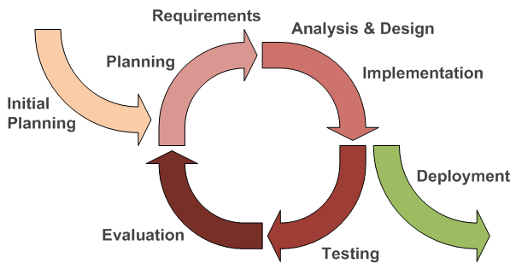

Figure 1: Iterative and Incremental development

### 2.2 Roles and responsibilities

|  |  |  |  |
| --- | --- | --- | --- |
| No | Full name | Team Role | Responsibilities |
| 1 | Nguyễn Đức Lợi | Supervisor, Project Manager | * Specify user requirement * Advisor for ideas and solutions * Give out techniques and business analysis support |
| 2 | Nguyễn Quang Huy | Team Leader, BA Developer, Tester | * Create test plan * Clarifying requirements * Prepare document * Coding * Testing |
| 3 | Nguyễn Tuấn Sang | Team Leader, BA, Developer, Tester | * Create test plan * Diving task for team member * Managing process * Clarifying requirements * Prepare document * Testing |
| 4 | Trần Hồng Sơn | BA, Developer, Tester | * Create test plan * Clarifying requirements * Prepare document * Coding * Testing |
| 5 | Mai Thanh Hiếu | BA, Developer, Tester | * Create test plan * Clarifying requirements * Prepare document * Coding * Testing |
| 6 | Huỳnh Quang Đạt | Developer, Tester | * Create test plan * Clarifying requirements * Prepare document * Coding * Testing |

Table 5: Detail Roles and responsibilities of Member

### 2.3 Tools and Techniques

|  |  |
| --- | --- |
| Tools | |
| Operating System | Windows 7/8/10 & Windows Server 2012 R2 |
| Developing tool | Arduino IDE, Visual Studio,  Notepad++, Sublime Text 3 |
| Source Control | Github |
| Managing Database | Navicat |
| Communication tool | Facebook, Skype, Slack |
| Model and Diagrams tool | Draw.io , Software Ideas Modeler, Fritzing, Creately.com |
| Testing | Postman |
| Programing language | |
| Arduino | C++ |
| Application | C#, JSON |
| Webserver | PHP, HTML, JSON, CakePHP 3.4 |

Table 6: Tools and Techniques use in project

## Project management plan

|  |  |  |  |  |  |
| --- | --- | --- | --- | --- | --- |
| Iteration | Scope | Evaluation | Activities | Estimated Duration | Assign Responsibilities |
| Initial Iteration | Initial team workplace and identify project scope | A working team environment | * Set up Git Repository with Gitflow * Set up Slack * Set up Trello | 5 days | SangNT,  HieuMT,  HuyNQ,  SonTH,  DatHQ |
| Iteration 1 | Identify boundaries of the system, planning software and hardware. Create a proof-of-concept prototype. | Report 1, Report 2 and a proof-ofconcept prototype | * Introduction document * Software and Hardware Project Management Plan document * Proof-ofconcept prototype | 15 days | SangNT,  HieuMT,  HuyNQ,  SonTH,  DatHQ |
| Iteration 2 | Produce an architectural prototype | Report 3, Report 4 and an architectural prototype | * Software and Hardware Requirement Specification document * Software and Hardware Design Description document * Architectural prototype | 15 days | SangNT,  HieuMT,  HuyNQ,  SonTH,  DatHQ |
| Iteration 3 | Build the product (up to beta release) | Report 5 and a working product (beta release) | * System Implementation and Test document * PCB * Application * Web API Server | 15 days | SangNT,  HieuMT,  HuyNQ,  SonTH,  DatHQ |
| Iteration 4 | Finish the product (full product release) | Report 6 and the completed product | * Software and Hardware User’s Manual document * Product demonstration model | 15 days | SangNT,  HieuMT,  HuyNQ,  SonTH,  DatHQ |
| Final Iteration | Prepare for Demo Day | Final Documentation, Presentation Slide | * Final Document * Mini Document * CD contains all source code * Presentation Slide | 5 days | SangNT,  HieuMT,  HuyNQ,  SonTH,  DatHQ |

Table 7: Project management plan

## Coding convention

* C/C++ Convention
  + C/C++: Using to develop program and solve algorithm on hardware.

Summary:

* Naming Convention:
* Using Pascal case for class name.
* Using Camel case for function, variable’s name.
* The #define and global variable’s name must uppercase and separate by underscore. Ex: GLOBAL_VARIABLE.
* Commenting Convention:
* Place the comment on the separate line with function.
* Place the comment at the end of the line, which has calculation formula.
* More details about coding conventions for C/C++ language by Google: https://google.github.io/styleguide/cppguide.html

# Hardware Requirement Specification

## User Requirement Specification

### 1.1 Train Requirement

Train is system where recognize magnetic and send signal to station. In train, CCU will calculate speed, send to station via RF module. To run all case, train must have power enough for CCU and run motor. Some function train run:

* Identify magnetic
* Calculate speed
* Send data to station, data include:
  + Four first characters: “ATC_” for encoding signal from train
  + Other characters is Speed of Train
* Receive warning signal in barrier

When train receive obstacle signal, LED in train will show and speaker will notification for driver to stop the train.

### 1.2 Assistant Requirement

Assistant only support for people. In Station, we put a button for pressing for Emergency. If have incident in station that can make accident with train, the assistant will press button send immediately message to the train. Only have a function for this:

* Send warning signal to train by pressing button

## Hardware Requirement Specification

### 2.1 Hardware Requirement

#### 2.1.1 Hardware Interface

The hardware interface must have satisfied the following requirements:

* Easy to maintenance
* Low-cost components
* Comfortable to implement

We decide choose following hardware components by detail

* Block diagram

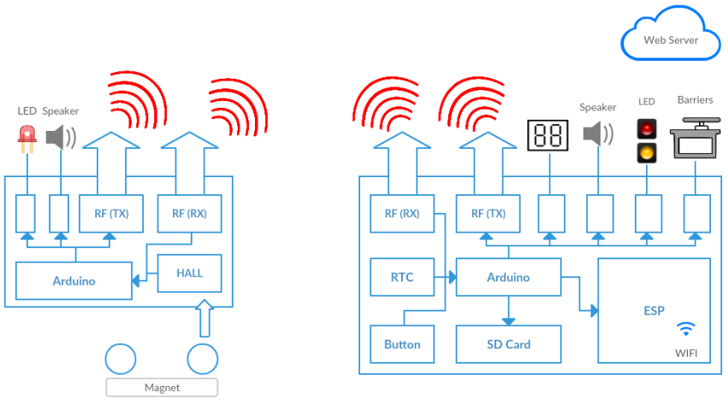

Figure 2: TWS Block Diagram

* Arduino Mega 2560

**Tech Specification**

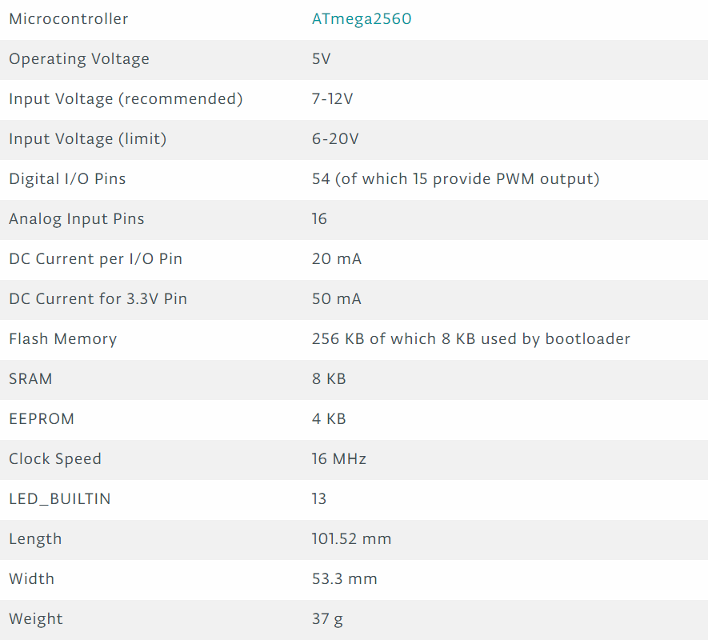

Figure 3: Tech specification’s Arduino Mega 2560

* Arduino Pro Mini

**Tech Specification**

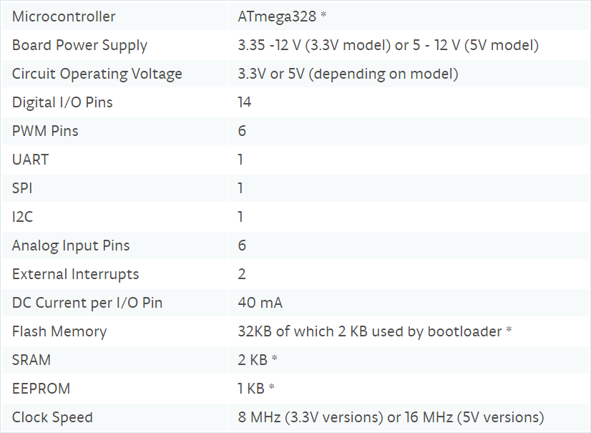

Figure 4: Tech specification’s Arduino Mini

* ESP8266 node MCU

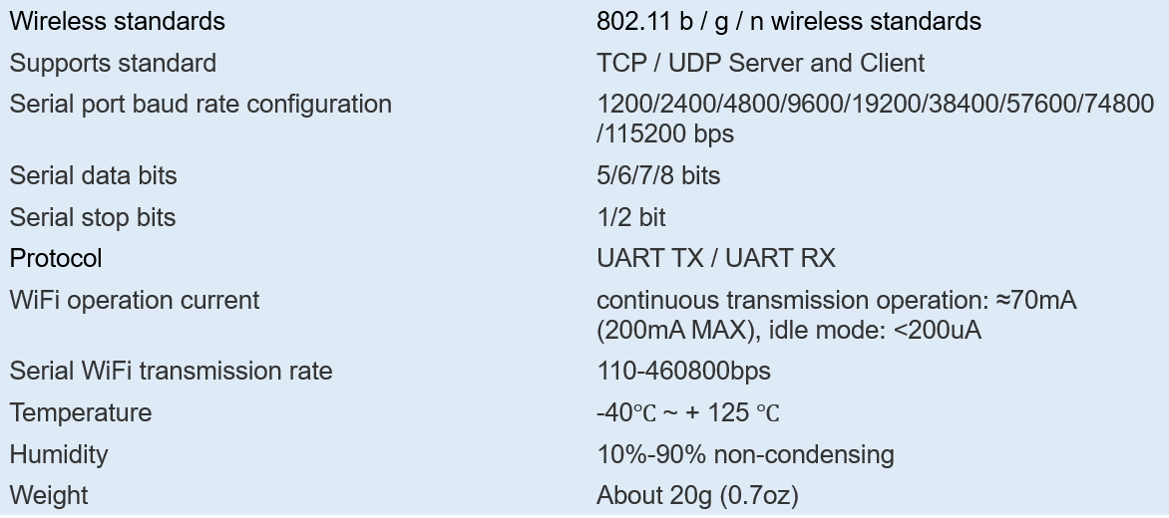**Tech Specification**

Figure 5: Tech specification’s ESP8266node MCU

* RF Module 315Mhz

**Tech Specification**

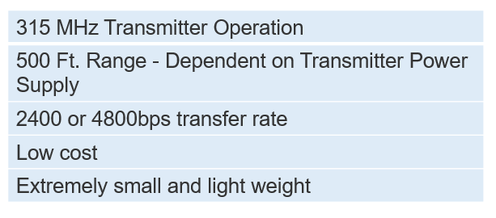

Figure 6: Tech specification’s RF Module 315Mhz

* Hall Sensor

**Tech Specification**

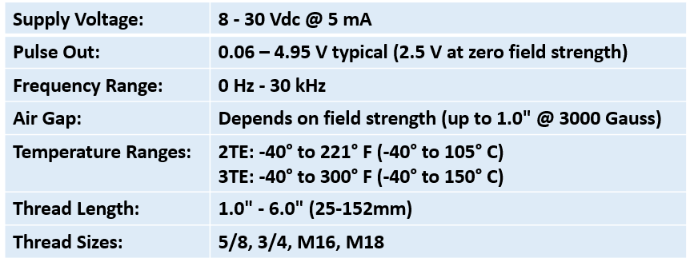

Figure 7: Tech specification’s Hall Sensor

* RTC DS1307

**Tech Specification**

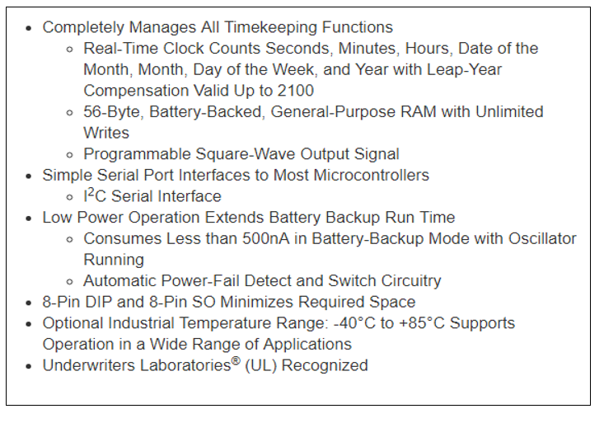

Figure 8: Tech specification’s RTC DS1307

* Micro SD Card Module

**Tech Specification**

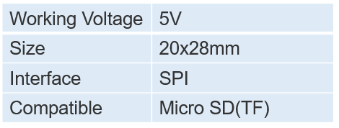

Figure 9: Tech specification’s MicroSD Card Module

* Speaker

**Tech Specification**

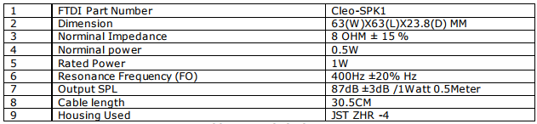

Figure 10: Tech specification’s Speaker

* LED seven-segment display

**Tech Specification**

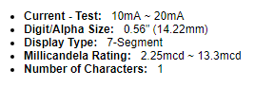

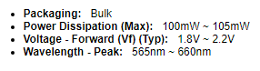

Figure 11: Tech specification’s LED Seven-Segment

* Servo

**Tech Specification**

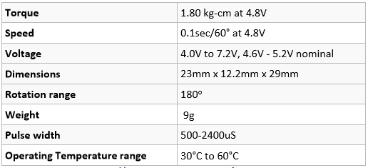

Figure 12: Tech specification’s Servo

* LED indicator

**Tech Specification**

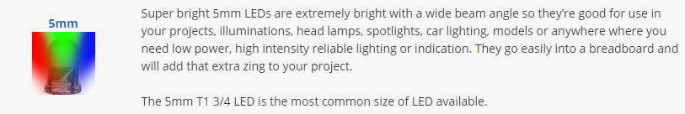

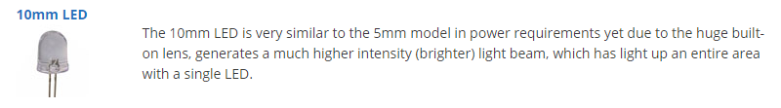

Figure 13: Tech specification’s LED indicator

#### Communication Protocol

##### I2C communication protocol

* I2C is a serial protocol for two-wire interface to connect low-speed devices like microcontrollers, EEPROMs, A/D and D/A converters, I/O interfaces and other similar peripherals in embedded systems. It was invented by Philips and now it is used by almost all major IC manufacturers. Each I2C slave device needs an address – they must still be obtained from NXP (formerly Philips semiconductors).

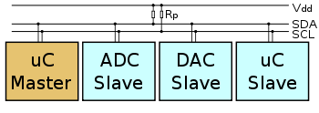

Figure 14: I2C communication protocol

* I2C uses only two wires: SCL (serial clock) and SDA (serial data). Both need to be pulled up with a resistor to +Vdd. There are also I2C level shifters which can be used to connect to two I2C buses with different voltages.

##### SPI communication protocol

* SPI is  is a [synchronous](https://en.wikipedia.org/wiki/Synchronous_circuit) [serial communication](https://en.wikipedia.org/wiki/Serial_communication) interface specification used for short distance communication, primarily in [embedded systems](https://en.wikipedia.org/wiki/Embedded_systems). The interface was developed by [Motorola](https://en.wikipedia.org/wiki/Motorola) in the late 1980s and has become a [de facto standard](https://en.wikipedia.org/wiki/De_facto_standard). Typical applications include [Secure Digital](https://en.wikipedia.org/wiki/Secure_Digital) cards and [liquid crystal displays](https://en.wikipedia.org/wiki/Liquid_crystal_display).

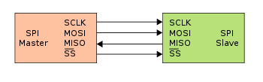

Figure 15: SPI communication protool

##### 2.1.2.3 GPIO pin

* GPIO is a generic pin on an [integrated circuit](https://en.wikipedia.org/wiki/Integrated_circuit) or computer board whose behavior—including whether it is an input or output pin—is controllable by the user at [run time](https://en.wikipedia.org/wiki/Run_time_(program_lifecycle_phase)).

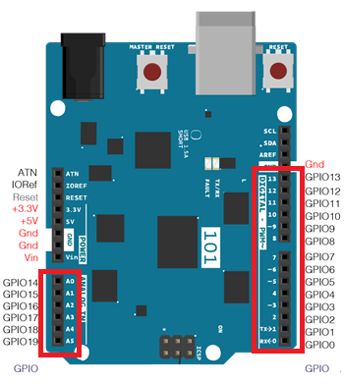

Figure 16: GPIO pin

##### 2.1.2.4 UART communication protocol

* UART or Universal Asynchronous Receiver Transmitter is a serial communication device that performs parallel – to – serial data conversion at the transmitter side and serial – to – parallel data conversion at the receiver side. It is universal because the parameters like transfer speed, data speed, etc. are configurable.

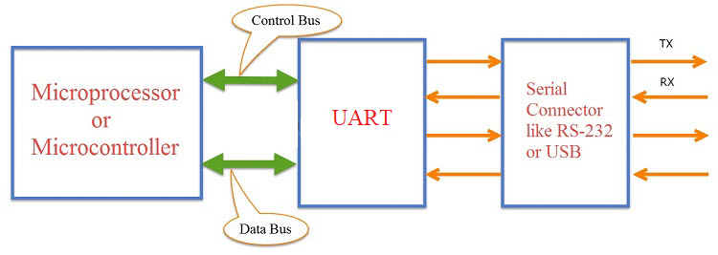

Figure 17: UART communication protocol

##### 2.1.2.5 Radio frequency communication protocol

* Radio frequency (RF) is any of the electromagnetic wave frequencies that lie in the range extending from around3 kHz to300 GHz, which include those frequencies used for communications or radar signals. RF usually refers to electrical rather than mechanical oscillations.

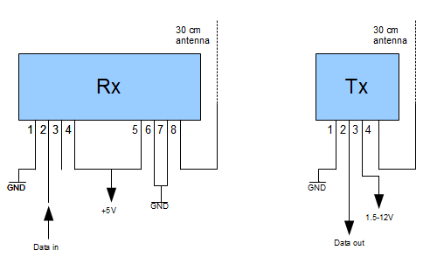

Figure 18: Radio frequency communication protocol

##### 2.1.2.6 Hypertext Transport Protocol

* HTTP is an application layer protocol that is used to transmit virtually all files and other data on the World Wide Web, whether they're HTML files, image files, query results, or anything else. Usually, HTTP takes place through TCP/IP sockets.

## Use Case Diagram

### 3.1 System Overview Use Case Diagram

Figure 19: Overview Use Case Diagram

### 3.2 List Of Use Case

#### 3.2.1 <Train> Use Case

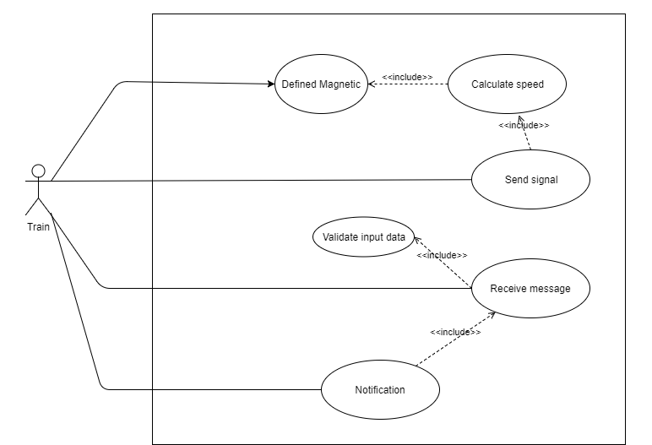

Figure 20: <Train>The train Use Case Diagram

##### 3.2.1.1 <Train> Defined Magnetic

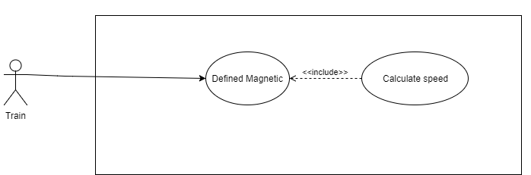

Figure 21: <Train>Defined magnetic Use Case Diagram

|  |  |  |  |
| --- | --- | --- | --- |
| **USE CASE – 1 specification** | | | |
| **Use Case No.** | **TWS 01** | **Use Case Version** | 2.0 |
| **Use Case Name** | Defined Magnetic | | |
| **Author** | Hoàng Phi Hồng | | |
| **Date** | 06/08/2017 | **Priority** | High |
| **Actor:**   * Train   **Summary:**   * The train defined magnetic on the railways.   **Goal:**   * This function defined the train nearly the station.   **Triggers:**   * The train run over magnetic.   **Preconditions:**   * The train run in railways.   **Post Conditions:**   * **Success:** The train defined magnetic on the railways. * **Fail:** N/A   **Main Success Scenario:**   |  |  |  | | --- | --- | --- | | Step | Actor Actions | System Response | | 1 | The train run over the first magnet | * System initialize time for the first magnet. | | 2 | The train run over the second magnet | * System minus the current time for the time was initialize in the first magnet. |   **Alternative Scenario:**   * N/A | | | |

Table 8: <Train>Defined magnetic

##### 3.2.1.2 <Train> Calculate Speed

**

Figure 22: <Train>Calculate Speed Use Case Diagram

|  |  |  |  |
| --- | --- | --- | --- |
| **USE CASE – 2 specification** | | | |
| **Use Case No.** | **TWS 02** | **Use Case Version** | 2.0 |
| **Use Case Name** | Calculate Speed | | |
| **Author** | Hoàng Phi Hồng | | |
| **Date** | 06/08/2017 | **Priority** | High |
| **Actor:**   * Train   **Summary:**   * Calculation speed of the train.   **Goal:**   * This function calculation speed of the train.   **Triggers:**   * The train run over two magnet .   **Preconditions:**   * The train run over two magnet .   **Post Conditions:**   * **Success:** Return speed of the train. * **Fail:** N/A   **Main Success Scenario:**   |  |  |  | | --- | --- | --- | | Step | Actor Actions | System Response | | 1 | The train run over two magnet. | * System calculation speed of train |   **Alternative Scenario:**   * N/A | | | |

Table 9: <Train>Calculate Speed

##### 3.2.1.3 <Train> Send Signal

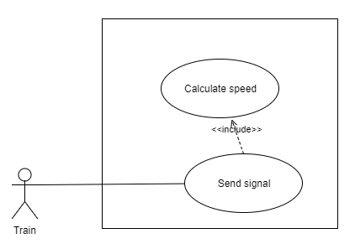

Figure 23: <Train>Send signal Use Case Diagram

|  |  |  |  |
| --- | --- | --- | --- |
| **USE CASE – 3 specification** | | | |
| **Use Case No.** | **TWS 03** | **Use Case Version** | 1.0 |
| **Use Case Name** | Send Signal | | |
| **Author** | Hoàng Phi Hồng | | |
| **Date** | 06/08/2017 | **Priority** | High |
| **Actor:**   * Train   **Summary:**   * Send signal to station.   **Goal:**   * Send speed of the train and notification to station that the train is coming.   **Triggers:**   * Calculation speed by distance of two magnet and time that the train run between two magnet.   **Preconditions:**   * The train run over two magnet . * System calculation speed of the train.   **Post Conditions:**   * **Success:** The train send message to station. * **Fail:** Message can not send.   **Main Success Scenario:**   |  |  |  | | --- | --- | --- | | Step | Actor Actions | System Response | | 1 | Send Speed | * System encode message by add to header of message string “ATC_” * System take speed and add to message. * Transfer data to module RF for send to station. |   **Alternative Scenario:**   * N/A | | | |

Table 10: <Train>Send signal

##### 3.2.1.4 <Train> Receive signal

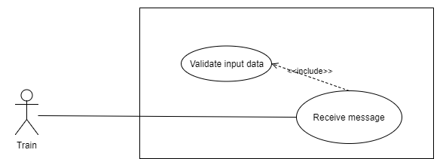

Figure 24: <Train>Receive signal Use Case Diagram

|  |  |  |  |
| --- | --- | --- | --- |
| **USE CASE – 4 specification** | | | |
| **Use Case No.** | **TWS 04** | **Use Case Version** | 1.0 |
| **Use Case Name** | Receive signal | | |
| **Author** | Hoàng Phi Hồng | | |
| **Date** | 07/08/2017 | **Priority** | High |
| **Actor:**   * Train   **Summary:**   * Receive signal from station.   **Goal:**   * Receive signal from station to warning for the train that in the station have incident then put notification warning to the train.   **Triggers:**   * The train run nearly the station. * The assistant in station press button emergency.   **Preconditions:**   * The train run nearly the station. * The assistant in station press button emergency.   **Post Conditions:**   * **Success:** The train put notification to train driver. * **Fail:** N/A.   **Main Success Scenario:**   |  |  |  | | --- | --- | --- | | Step | Actor Actions | System Response | | 1 | Receive message | * System receive message by module RF | | 2 | Validate input data | * System will check message correct format “SOS”. |   **Alternative Scenario:**   * N/A   **Exceptions:**   * The module RF receive signal interference of another module RF, this signal will be reject by validate input data. | | | |

Table 11: <Train>Receive signal

##### 3.2.1.5 <Train> Notification

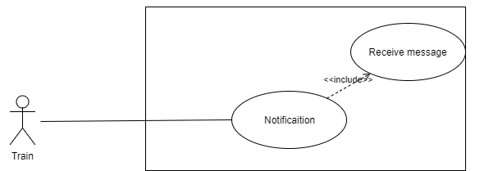

Figure 25: <Train>Notification Use Case Diagram

|  |  |  |  |
| --- | --- | --- | --- |
| **USE CASE – 5 specification** | | | |
| **Use Case No.** | **TWS 05** | **Use Case Version** | 1.0 |
| **Use Case Name** | Notification | | |
| **Author** | Hoàng Phi Hồng | | |
| **Date** | 07/08/2017 | **Priority** | High |
| **Actor:**   * Train   **Summary:**   * Notification to train driver.   **Goal:**   * Notification to train driver to know that in the station have incident to handle situation.   **Triggers:**   * The assistant in station press button emergency. * The train receive message warning.   **Preconditions:**   * The train run nearly the station. * The assistant in station press button emergency. * The train receive message warning.   **Post Conditions:**   * **Success:** The train put notification to train driver. * **Fail:** N/A.   **Main Success Scenario:**   |  |  |  | | --- | --- | --- | | Step | Actor Actions | System Response | | 1 | Receive message | * System receive message by module RF | | 2 | Notification | * System turn on speaker and Led notification to train driver. |   **Alternative Scenario:**   |  |  |  | | --- | --- | --- | | Step | Actor Actions | System Response | | 1 | Turn off notification | * When system on the train do not receive message of the station that mean incident in station have to resolve, System will turn off notification and the train can continue run. |   **Exceptions:**   * N/A | | | |

Table 12: <Train>Notification

#### 3.2.2 <Assistant> Warning train

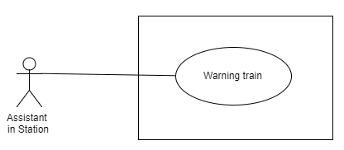

Figure 26: <Assistant>Warning train Use Case Diagram

|  |  |  |  |
| --- | --- | --- | --- |
| **USE CASE – 6 specification** | | | |
| **Use Case No.** | **TWS 06** | **Use Case Version** | 1.0 |
| **Use Case Name** | Warning train | | |
| **Author** | Hoàng Phi Hồng | | |
| **Date** | 07/08/2017 | **Priority** | High |
| **Actor:**   * Assitant   **Summary:**   * If in the station have incident that can not resolve immediately, the assistant will press button for warning to the train.   **Goal:**   * Active module RF for send message to the train for warning incident at the station that can not resolve immediately.   **Triggers:**   * The assistant press button emergency.   **Preconditions:**   * Have incident at the station. * Assistant press button emergency   **Post Conditions:**   * **Success:** The module RF send message. * **Fail:** N/A.   **Main Success Scenario:**   |  |  |  | | --- | --- | --- | | Step | Actor Actions | System Response | | 1 | Press button emergency | * System compare message with string “SOS”. |   **Alternative Scenario:**   * N/A | | | |

Table 13: <Assistant>Warning train

`

#### 3.2.3 <Station> Use Case

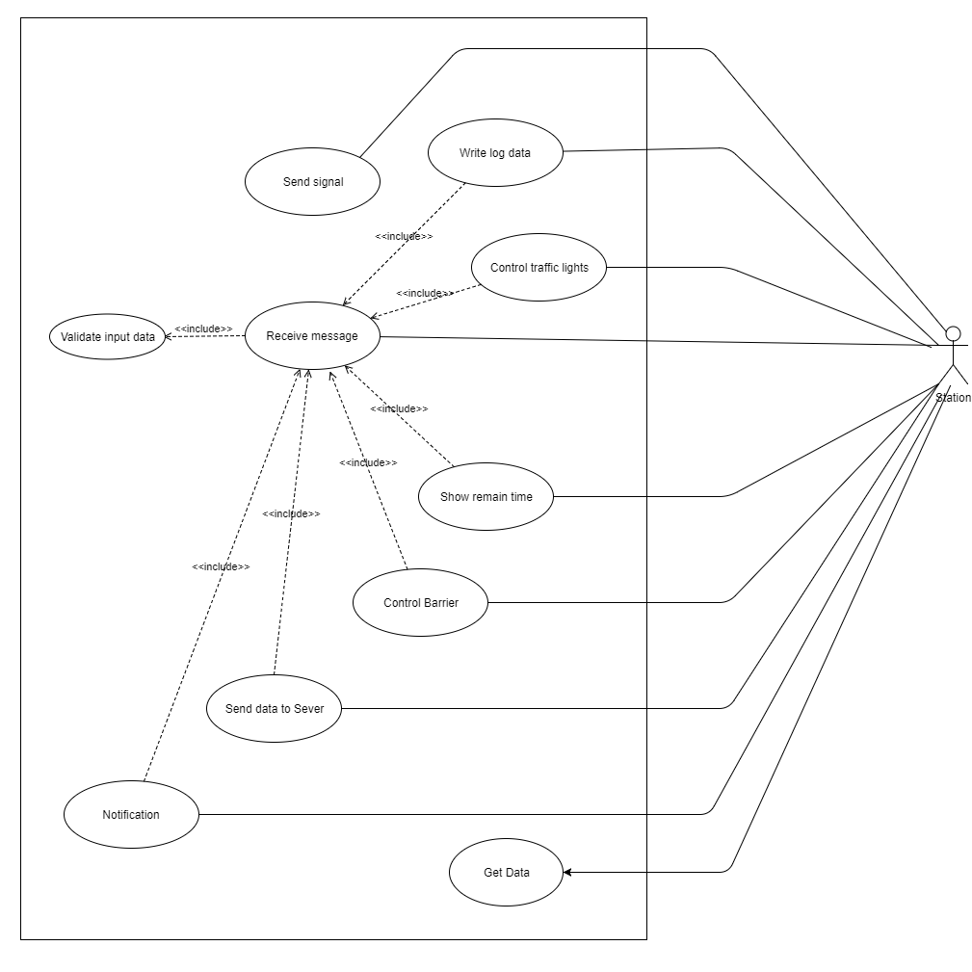

Figure 27: <Station>Station Use Case Diagram

##### 3.2.3.1 <Station> Receive Message

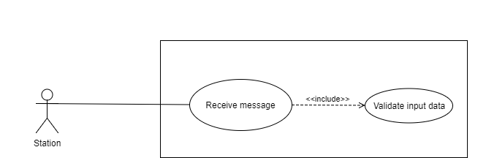

Figure 28: <Station>Receive message Use Case Diagram

|  |  |  |  |
| --- | --- | --- | --- |
| **USE CASE – 7 specification** | | | |
| **Use Case No.** | **TWS 07** | **Use Case Version** | 1.0 |
| **Use Case Name** | Receive message | | |
| **Author** | Hoàng Phi Hồng | | |
| **Date** | 07/08/2017 | **Priority** | High |
| **Actor:**   * Station   **Summary:**   * When the train run over two magnet, the train send a message to the station, The station receive and validate message.   **Goal:**   * Receive message of the train for know that speed of the train.   **Triggers:**   * The train run over two magnet and send message.   **Preconditions:**   * The train send message.   **Post Conditions:**   * **Success:** Receive all message from the train. * **Fail:** Reject signal interference of another RF module.   **Main Success Scenario:**   |  |  |  | | --- | --- | --- | | Step | Actor Actions | System Response | | 1 | Receive message | * System receive message by RF module | | 2 | Validate message | * Validate the message that the header of message matches with header of message send by the train. The message have string “ATC_” in header. |   **Alternative Scenario:**   * N/A   **Exceptions:**   * The module RF receive signal interference of another module RF, this signal will be reject by validate input data. | | | |

Table 14: <Station>Receive message

##### 3.2.3.2 <Station> Write Log Data

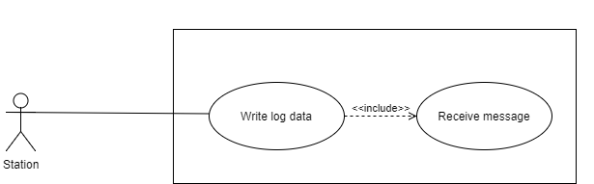

Figure 29: <Station>Write log data Use Case Diagram

|  |  |  |  |
| --- | --- | --- | --- |
| **USE CASE – 8 specification** | | | |
| **Use Case No.** | **TWS 08** | **Use Case Version** | 1.0 |
| **Use Case Name** | Write log data | | |
| **Author** | Hoàng Phi Hồng | | |
| **Date** | 07/08/2017 | **Priority** | Medium |
| **Actor:**   * Station   **Summary:**   * The controller will get time in module Real Time Clock and take speed when receive message and combine them for write to micro SD card.   **Goal:**   * Write log time when the train come to station and speed at that time.   **Triggers:**   * The station receive message contain speed of the train.   **Preconditions:**   * The station receive message contain speed of the train .   **Post Conditions:**   * **Success:** Write data success with data is current time and speed of train. * **Fail:** Can not write log data.   **Main Success Scenario:**   |  |  |  | | --- | --- | --- | | Step | Actor Actions | System Response | | 1 | Get current time | * System will get cuurent time in module Real Time Clock with format HH:MM:ss Wday YY/MM/DD | | 2 | Take Speed | * System will take speed form message and link with date time. | | 3 | Write Log Data | * System open file in micro SD card and write data to this file. |   **Alternative Scenario:**   * N/A   **Exceptions:**   * Time of module Real Time Clock (RTC) is wrong, module RTC uses external battery so that when low of battery that make module RTC can not run. * Memory free in micro SD card do not enough. | | | |

Table 15: <Station>Write log data

##### 3.2.3.3 <Station> Send data to server

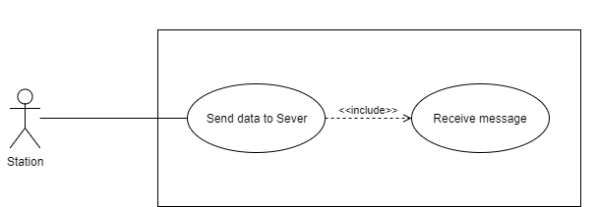

Figure 30: <Station>Send data to server Use Case Diagram

|  |  |  |  |
| --- | --- | --- | --- |
| **USE CASE – 9 specification** | | | |
| **Use Case No.** | **TWS 09** | **Use Case Version** | 1.0 |
| **Use Case Name** | Send data to server | | |
| **Author** | Hoàng Phi Hồng | | |
| **Date** | 08/08/2017 | **Priority** | High |
| **Actor:**   * Station   **Summary:**   * Send speed of the train to server for store speed in cloud and notification to computer in station.   **Goal:**   * Send speed anf store in server.   **Triggers:**   * The station receive message contain speed of the train.   **Preconditions:**   * The station receive message contain speed of the train. * Module ESP8266 nodeMCU connected to wifi.   **Post Conditions:**   * **Success:** Speed of the train store in cloud. * **Fail:** Can not send data.   **Main Success Scenario:**   |  |  |  | | --- | --- | --- | | Step | Actor Actions | System Response | | 1 | Send speed | * Controller receive message contain speed and send that to module ESP8266 nodeMCU. * Module Esp8266 will send speed of the train |   **Alternative Scenario:**   * N/A   **Exceptions:**   * Module ESP8266 nodeMCU can not connect to wifi. | | | |

Table 16: <Station>Send data to server

##### 3.2.3.4 <Station> Control traffic lights

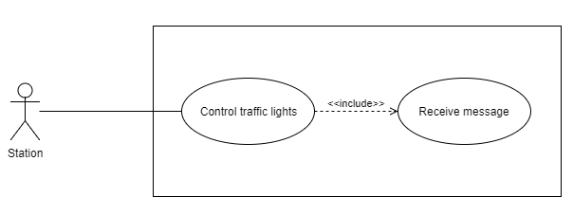

Figure 31: <Station>Control traffic light Use Case Diagram

|  |  |  |  |
| --- | --- | --- | --- |
| **USE CASE – 10 specification** | | | |
| **Use Case No.** | **TWS 10** | **Use Case Version** | 1.0 |
| **Use Case Name** | Control traffic lights | | |
| **Author** | Hoàng Phi Hồng | | |
| **Date** | 08/08/2017 | **Priority** | High |
| **Actor:**   * Station   **Summary:**   * Control traffic lights, yellow light turn on to make transportation slow down their speed. * If time remain 15s the yellow light will turn off after that the red light will turn on.   **Goal:**   * Control traffic lights to make everyone stops when the train arrives.   **Triggers:**   * The station receive message contain speed of the train.   **Preconditions:**   * The station receive message contain speed of the train.   **Post Conditions:**   * **Success:** Traffic lights turn on and everyone stop. * **Fail:** N/A.   **Main Success Scenario:**   |  |  |  | | --- | --- | --- | | Step | Actor Actions | System Response | | 1 | Turn on Yellow light | * System calculation time remain the train go to station. * If the time remain more than 15 seconds, time yellow light turn on is time minus for 15 seconds. | | 2 | Turn on Red light | * When time remain is 15 seconds system will turn of yellow light then turn on red light. |   **Alternative Scenario:**   |  |  |  | | --- | --- | --- | | Step | Actor Actions | System Response | | 1 | Turn off traffic lights | * The remain time is 0 seconds system will turn off traffic lights. |   **Exceptions:**   * N/A | | | |

Table 17: <Station>Control traffic light

##### 3.2.3.5 <Station> Show remain time

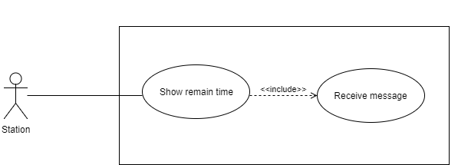

Figure 32: <Station>Show remain time Use Case Diagram

|  |  |  |  |
| --- | --- | --- | --- |
| **USE CASE – 11 specification** | | | |
| **Use Case No.** | **TWS 11** | **Use Case Version** | 1.0 |
| **Use Case Name** | Show remain time | | |
| **Author** | Hoàng Phi Hồng | | |
| **Date** | 08/08/2017 | **Priority** | High |
| **Actor:**   * Station   **Summary:**   * Base on speed, system will calculation time remain and show it to led seven segment.   **Goal:**   * Show for every ones know time remain the train will go to station.   **Triggers:**   * The station receive message contain speed of the train.   **Preconditions:**   * The station receive message contain speed of the train.   **Post Conditions:**   * **Success:** The led seven segment show time remain. * **Fail:** N/A.   **Main Success Scenario:**   |  |  |  | | --- | --- | --- | | Step | Actor Actions | System Response | | 1 | Show time remain | * System calculation time remain. * Countdown time and show it to led seven segment. |   **Alternative Scenario:**   |  |  |  | | --- | --- | --- | | Step | Actor Actions | System Response | | 1 | Turn off led seven segment | * The remain time is 0 seconds system will turn off led seven segment. |   **Exceptions:**   * N/A | | | |

Table 18: <Station>Show remain time

##### 3.2.3.6 <Station> Control barrier

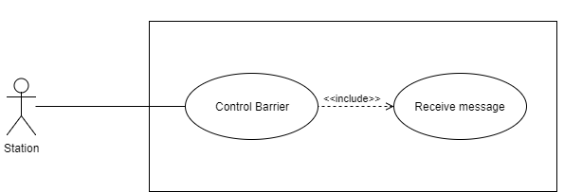

Figure 33: <Station>Control barrier Use Case Diagram

|  |  |  |  |
| --- | --- | --- | --- |
| **USE CASE – 12 specification** | | | |
| **Use Case No.** | **TWS 12** | **Use Case Version** | 1.0 |
| **Use Case Name** | Control Barrier | | |
| **Author** | Hoàng Phi Hồng | | |
| **Date** | 08/08/2017 | **Priority** | High |
| **Actor:**   * Station   **Summary:**   * Barrier low down when train arrives.   **Goal:**   * Prevent people from going to the railroad when the train arrives.   **Triggers:**   * The station receive message contain speed of the train.   **Preconditions:**   * The station receive message contain speed of the train.   **Post Conditions:**   * **Success:** The barrier low down. * **Fail:** N/A.   **Main Success Scenario:**   |  |  |  | | --- | --- | --- | | Step | Actor Actions | System Response | | 1 | Low down barrier | * System calculation time remain. * When time remain is 15 seconds system will low down the barrier. |   **Alternative Scenario:**   |  |  |  | | --- | --- | --- | | Step | Actor Actions | System Response | | 1 | Put up barrier | * The remain time is 0 seconds system will put up the barrier |   **Exceptions:**   * N/A | | | |

Table 19: <Station>Control barrier

##### 3.2.3.7 <Station> Notification

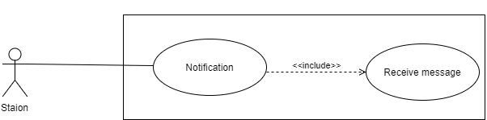

Figure 34: <Station>Notification Use Case Diagram

|  |  |  |  |
| --- | --- | --- | --- |
| **USE CASE – 13 specification** | | | |
| **Use Case No.** | **TWS 13** | **Use Case Version** | 1.0 |
| **Use Case Name** | Notification | | |
| **Author** | Hoàng Phi Hồng | | |
| **Date** | 08/08/2017 | **Priority** | High |
| **Actor:**   * Station   **Summary:**   * Uses Speaker to notification to everyone know the train is coming.   **Goal:**   * Notification to everyone stop before the train arrives at the station.   **Triggers:**   * The station receive message contain speed of the train.   **Preconditions:**   * The station receive message contain speed of the train.   **Post Conditions:**   * **Success:**Operates loudspeaker warning system to everyone. * **Fail:** N/A.   **Main Success Scenario:**   |  |  |  | | --- | --- | --- | | Step | Actor Actions | System Response | | 1 | Notification | * The system will activate the warnng speaker with sound: “Cảnh báo tàu đang tới”. |   **Alternative Scenario:**   |  |  |  | | --- | --- | --- | | Step | Actor Actions | System Response | | 1 | Turn off notification | * The remain time is 0 seconds system will turn off the speaker. |   **Exceptions:**   * N/A | | | |

Table 20: <Station>Notification

##### 3.2.3.8 <Station> Get data

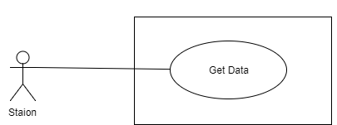

Figure 35: <Station>Get data Use Case Diagram

|  |  |  |  |
| --- | --- | --- | --- |
| **USE CASE – 14 specification** | | | |
| **Use Case No.** | **TWS 14** | **Use Case Version** | 1.0 |
| **Use Case Name** | Get data | | |
| **Author** | Hoàng Phi Hồng | | |
| **Date** | 08/08/2017 | **Priority** | High |
| **Actor:**   * Station   **Summary:**   * System get data from server to notification with assistant at station..   **Goal:**   * Synchronous data form server with computer at station and notification to assistant.   **Triggers:**   * The station receive message contain speed of the train.   **Preconditions:**   * The station receive message contain speed of the train.   **Post Conditions:**   * **Success:**System put notification in computer. * **Fail:** N/A.   **Main Success Scenario:**   |  |  |  | | --- | --- | --- | | Step | Actor Actions | System Response | | 1 | Get data | * Continuous system get data from server 1 minutes per times. | | 2 | Notification | * System will calculation time remain after that display that to screen and notification by speaker |   **Alternative Scenario:**   * N/A   **Exceptions:**   * N/A | | | |

Table 21: <Station>Get data

## Software System Attribute

### 4.1 Usability

* + Users can install the system easily.
  + There are books that guide the installation of controllers in trains and stations.
  + The system is divided into several components to facilitate the installation into maintenance.

### 4.2 Reliability

* + The system uses barrier to ensure safety for the driver.
  + The fully automated system does not depend on humans.
  + The logging system at the station and on the cloud helps to verify the log.

### 4.3 Availability

* + The system operates continuously 24/24.

### 4.4 Security

* + The message is encoded to ensure accuracy.

### 4.5 Maintainability

* + The system is subdivided into modules so it is easy to replace.
  + Assistants are trained in system knowledge to be able to replace broken modules immediately.

### 4.6 Portability

* + N/A

### 4.7 Performance

* + Stable operation in all weather conditions.

## Conceptual Diagram



Figure 36: Conceptual Diagram

|  |  |
| --- | --- |
| Entity Data dictionary: describe all content of all entities | |
| Entity Name | Description |
| Train | Abstract entity describes the train in system |
| Station | Abstract entity describes the station in system |
| Railway | The railway of the train |
| Magnet | The magnet put into the railway |
| Sensor | This is hall sensor for detect the magnet |
| Cloud | That is where store speed of the train |
| Seven-segment display | Show remain time |
| Speaker | Notification to driver |
| Traffic lights | Control traffic |
| Barrier | Prevent people go to railway |
| Micro SDcard | Log current time and speed of the train |
| Computer | Synchronous data form server and notification to assistant |

Table 22 Conceptual Diagram data dictionary:

# Software Project Management Plan

## Design Overview

* This document describes the technical and user interface design of TWS. It includes the architectural design, the detailed design of common functions and business functions and the design of database model.
* The architectural design describes the overall architecture of the system and the architecture of each main component and subsystem.
* The detailed design describes static and dynamic structure for each component and functions. It includes class diagrams, class explanations and sequence diagrams for each use case.
* Document overview:
* Section 2: gives an overall description of the system architecture design.
* Section 3: gives component diagrams that describe the connection and integration of the system.
* Section 4: gives the detail design description which includes class diagram, class explanation, and sequence diagram to details the application functions.
* Section 5: describe screen design.
* Section 6: describe algorithms.

## System Architecture Design

According to requirements of the train warning system at the railway crossing, the design below is the system architecture. It includes 2 main hubs: train and control, which are communicate via RF module inside of each.

### 2.1 System Architect Design

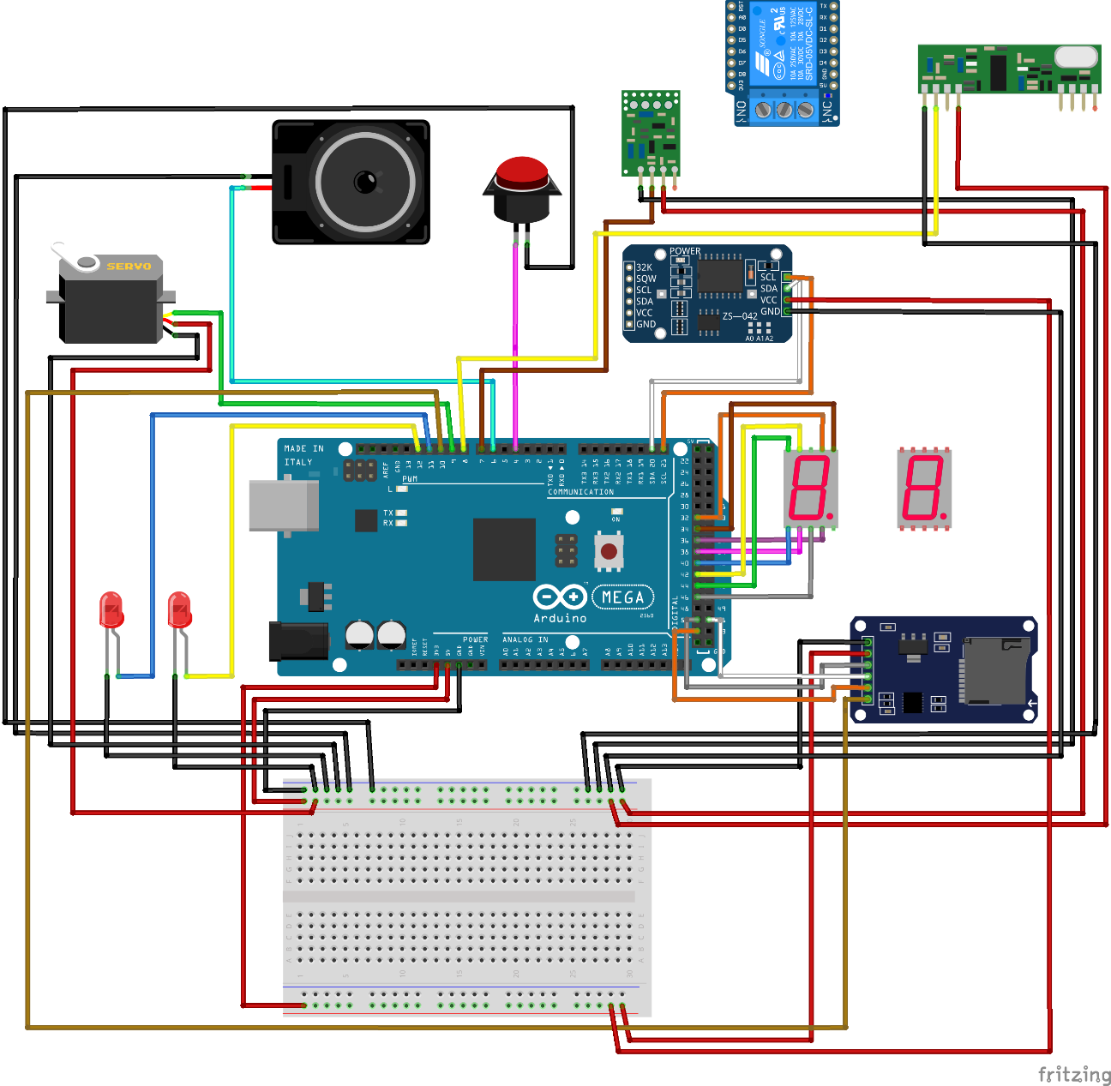

Figure 37: <Station> System Architecture Design

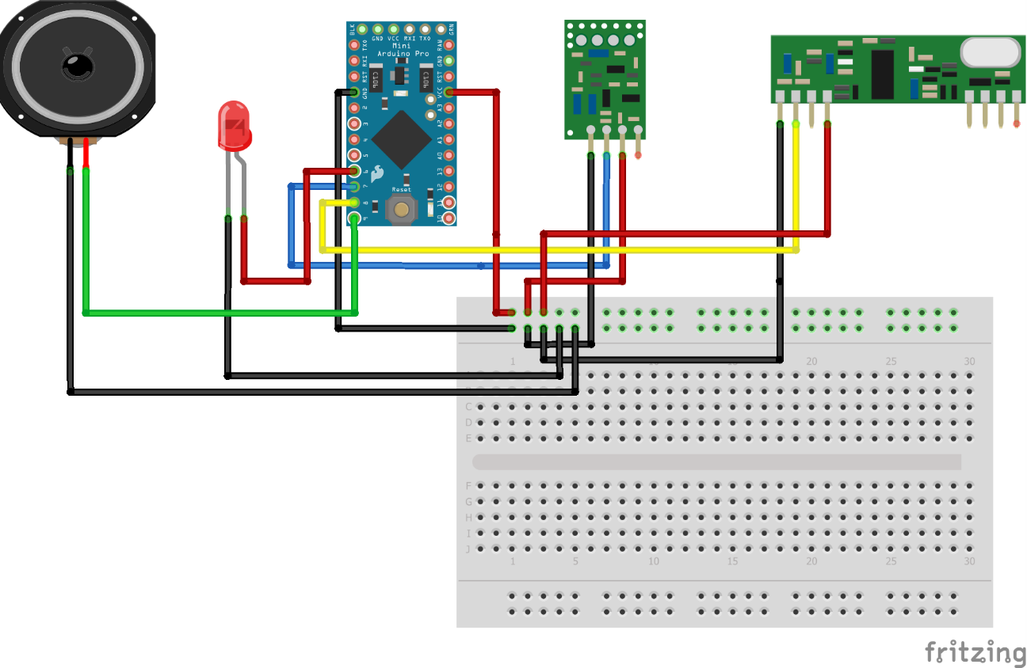

Figure 38: <Train> System Architecture Design

### 2.2 Hardware Program Architecture Description

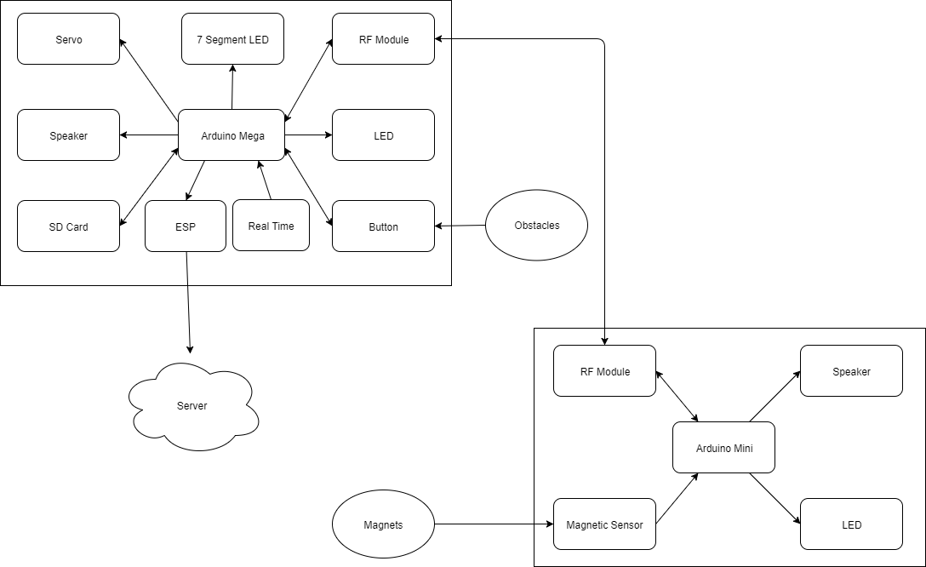

Figure 39: Hardware Program Architecture

* **Arduino Mega:** plays the roles as central processing unit Train and Control System.

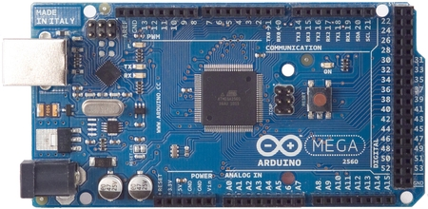

Figure 40: Arduino Mega

* **Arduino Mini**: plays the roles as central processing unit Train and Control System.

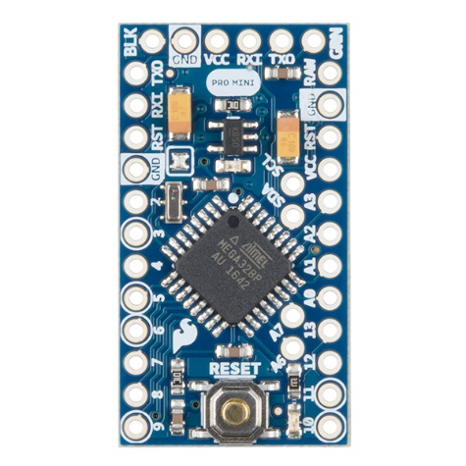

Figure 41: Arduino Mini

* **Servo**: a linear actuator that allows for precise control of angular or linear position, velocity and acceleration. This will be used to control the barrier in road junction.

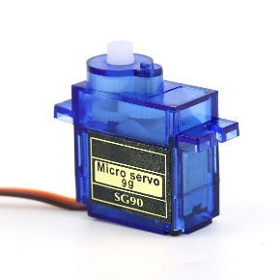

Figure 42: Servo

* **7 Segment LED**: a set of seven bar-shaped LED (light-emitting diode) elements, arranged to form a squared-off figure 8. It displays the time left when will the train comes crossroad.

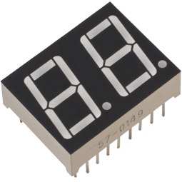

Figure 43: Seven-Segment LED

* **RF Module**: a small device uses to transmit/receive radio signals between two devices. This is used to create a network bridge for the whole system.

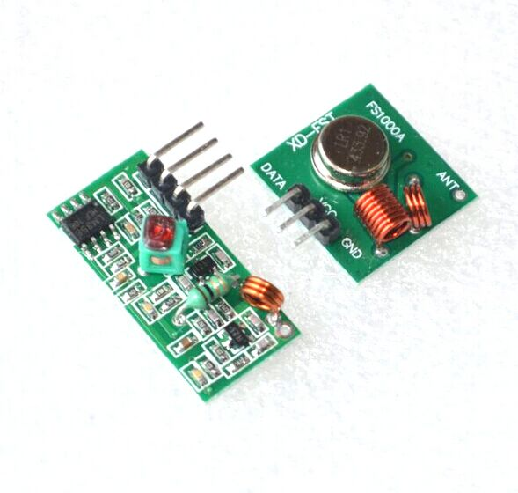

Figure 44: RF Module

* **LED**: a large LED display screen. It uses for warning people in driving when the train is coming.

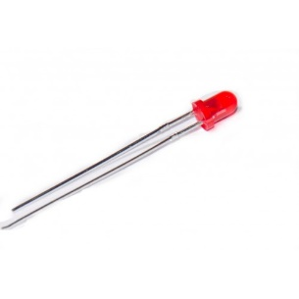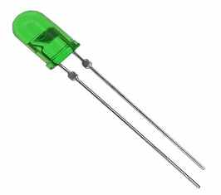

Figure 45: LED

* **Speaker**: another type of warning system, helping people more attention when the train is coming.

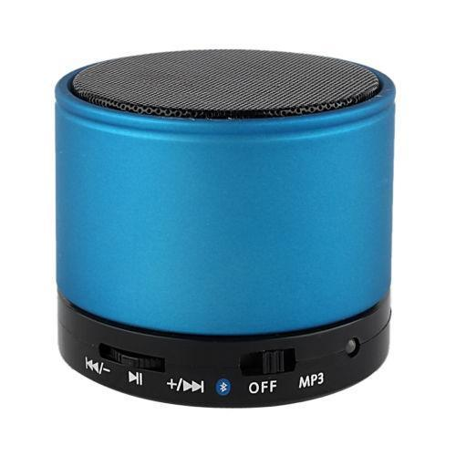

Figure 46: Speaker

* **SD Card reader**: a device used to reader data from Micro SD Card.

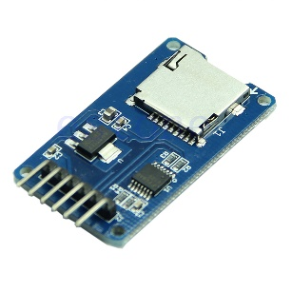

Figure 47: Micro SD Card reader

* **Realtime (RTC** **DS1307):** accurate real-time clock (RTC) with an integrated temperature-compensated crystal oscillator (TCXO) and crystal. It catches up the time for writing data history.

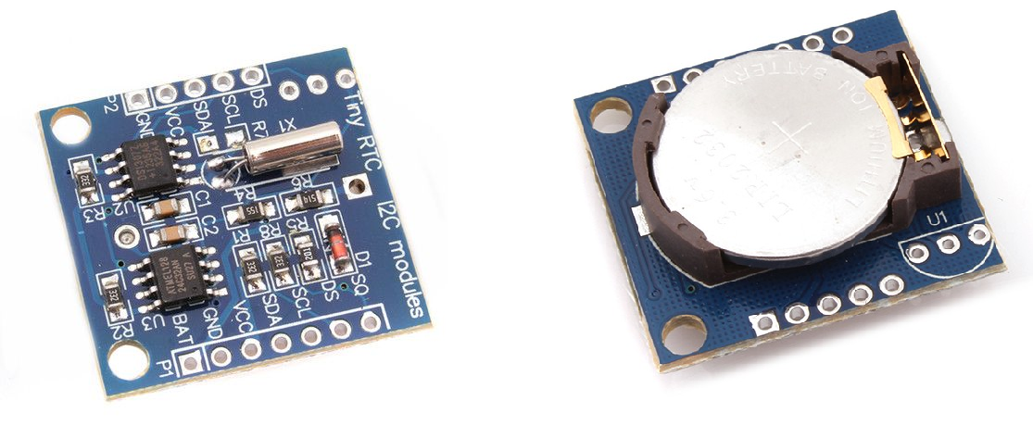

Figure 48: Real Time Circus (RTC DS1307)

* **Magnetic Sensor:**  is a transducer that varies its output voltage in response to a magnetic field. It is used for proximity switching, positioning, speed detection, and current sensing applications.

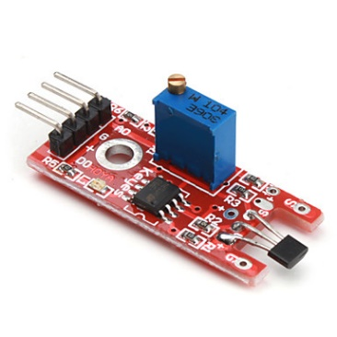

Figure 49: Magnetic Sensor

* **ESP8266 Node MCU:** This WiFi Internet of Things (IOT) module. Embed Wi-Fi capabilities within other systems. As in our project, ESP8266 Node MCU is a connector to Webservice.

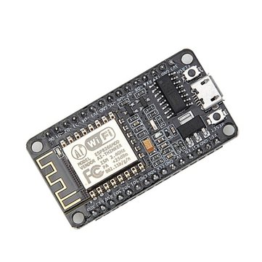

Figure 50: ESP8266 Node MCU

### 2.3 Software Program Architecture Description

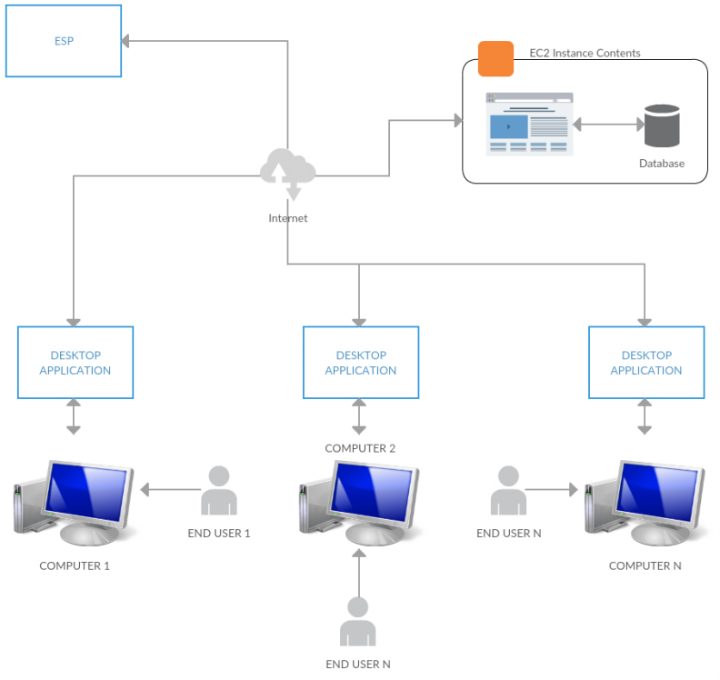

Figure 51: Software Program Architectual Description

## Component Diagram

### 3.1 General Component Diagram

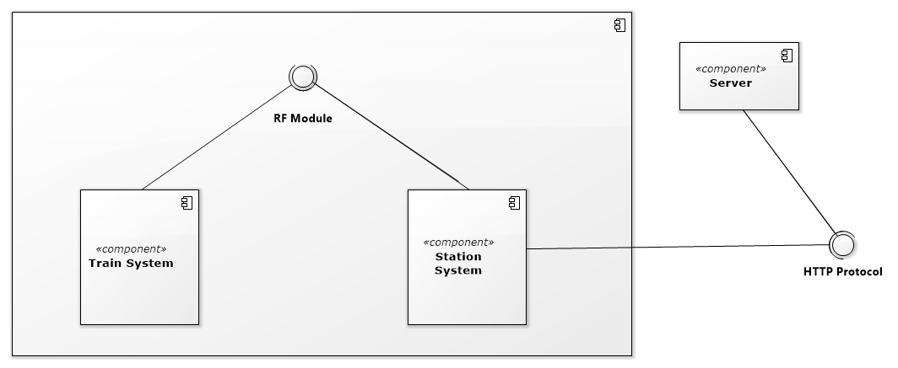

Figure 52: General Component Diagram

### 3.2 Train System Component Diagram

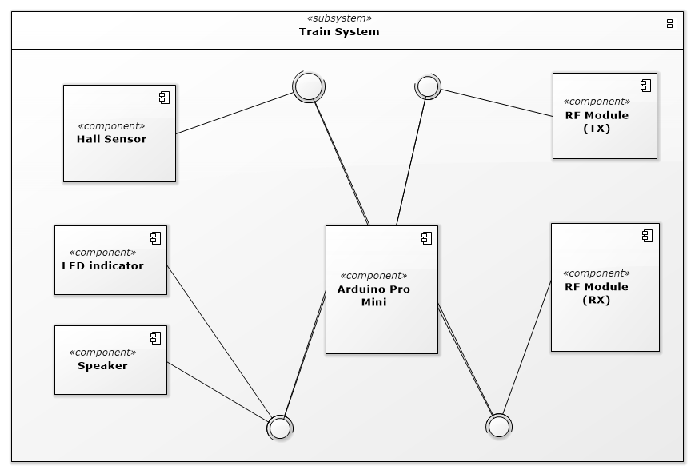

Figure 53: Train System Component Diagram

### 3.3 Station System Component Diagram

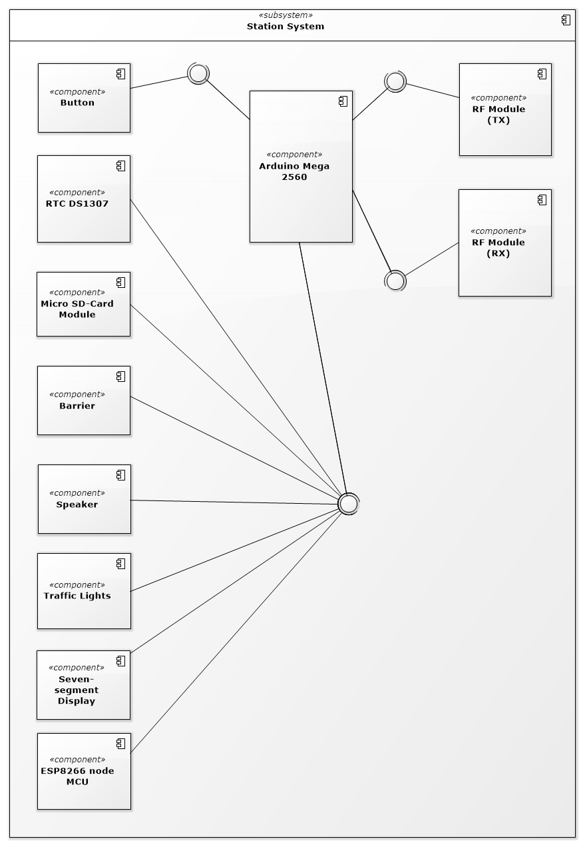

Figure 54: Station System Component Diagram

### 3.4 Component Diagram Data Dictionary

|  |  |
| --- | --- |
| **Component Dictionary: Describes components** | |
| Server | The Web API server, which make the interaction between the Cloud and the ESP8266 nodeMCU. It also save information to the database. |
| Wifi Module | ESP8266 nodeMCU, to connect hardware component with server |
| Station System | Main controller to receive warning data |
| Train System | To receive magnet signal to send Station |
| RF Module | Communicate between Station and train |
| Arduino Pro Mini | Main CCU control in Train system |
| Hall Sensor | Detect Magnet sending to CCU |
| LED indicator | Warning object deal with train by visual |
| Arduino Mega 2560 | CCU of Station system, control all notification process |
| RTC DS1307 | Get real time and update time in Arduino clock input |
| Micro SD-Card Module | Store Speed and time data of Train cross over barrier |
| Barrier | Simulator barrier, default status is up, when train coming, Barrier down to stop vehicles |
| Speaker | Warning train coming by hearing  “Cảnh báo tàu đang đến”. |
| LED seven-segment display | Show the remain time when the train come to the staion. |

Table 23: Component Diagram Data Dictionary

## Detailed Description

### 4.1 Embedded Program Detailed Description

#### 4.1.1 Class Diagram

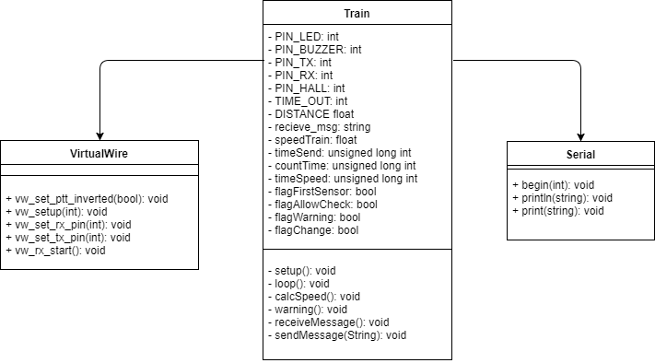

Figure 55: Train class diagram

|  |  |
| --- | --- |
| **Class Dictionary: describes class** | |
| **Class name** | **Description** |
| Train [Main] | Core program of train. |
| VirtualWire | Virtual Wire provides features to support RF module. |
| Serial | Serial provides a cross platform interface for interacting with Serial Ports. |

Table 24: Train class diagram dictionary

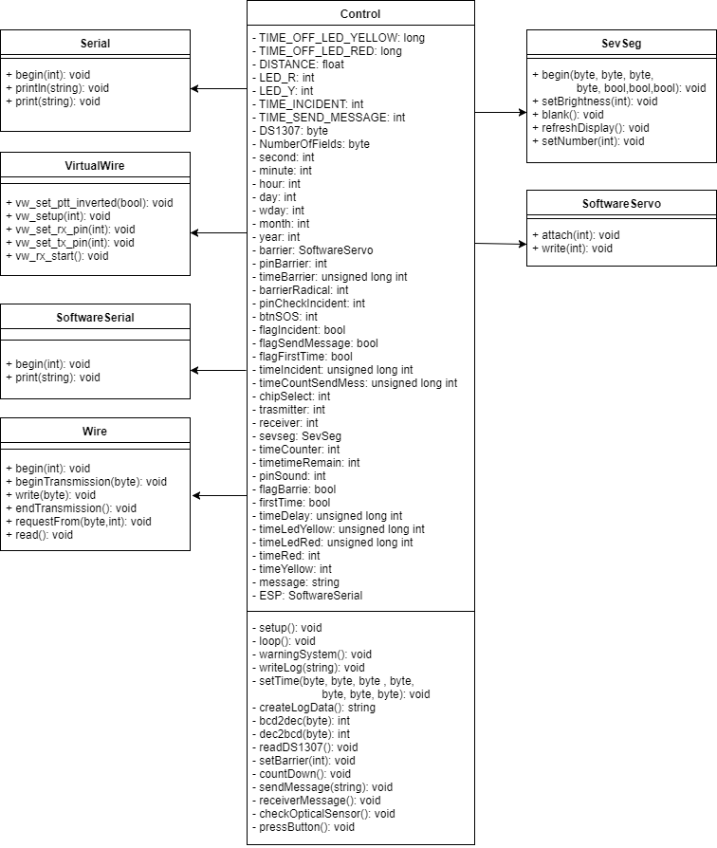

Figure 56: Control class diagram

|  |  |
| --- | --- |
| **Class Dictionary: describes class** | |
| **Class name** | **Description** |
| Control [Main] | Core program of control station. |
| Serial | Serial provides a cross platform interface for interacting with Serial Ports. |
| VirtualWire | Virtual Wire provides features to support RF module. |
| SoftwareSerial | Software Serial  allow serial communication on other digital pins of the Arduino. |
| Wire | Wire allows to communicate with I2C devices. |
| SevSeg | SevSeg uses to display numbers on seven segment display. |
| SoftwareServo | Software Servo can drive servos on all of pins simultaneously. |

Table 25: Control class diagram dictionary

#### 4.1.2 Class Diagram Explanation

##### 4.1.2.1 Train Diagram Explanation

###### 4.1.2.1.1 [Train] Main

* **Attributes**

|  |  |  |  |
| --- | --- | --- | --- |
| **Attribute** | **Type** | **Visibility** | **Description** |
| PIN_LED | Int | Private | Pin user for LED. |
| PIN_BUZZER | Int | Private | Pin user for BUZZER. |
| PIN_TX | Int | Private | Pin user for TX of RF. |
| PIN_RX | Int | Private | Pin user for RX of RF. |
| PIN_HALL | Int | Private | Pin user for Hall sensor. |
| TIME_OUT | Int | Private | Define a variable to check time between two magnetic have been detected. |
| DISTANCE | Int | Private | Distance between two magnetic on prototype. |
| receiveMsg | String | Private | A message receives from Control Station. |
| timeSend | Long | Private | A variable handle time to make Led display smoother. |
| countTime | Long | Private | A number of times that warning system is runned. |
| speedTrain | Float | Private | Store the speed of train. |
| flagFirstSensor | boolean | Private | Flag to check the first magnetic has been detected. |
| flagAllowCheck | boolean | Private | Flag to check the second magnetic has been detected. |
| flagWarning | boolean | Private | Flag to check the dangerous situations is existed or not. |
| flagChange | boolean | Private | Flag to handle status of warning system is on or off. |
| timeSpeed | Long | Private | Store the time of each magnetic when sensor detected. |

Table 26: [Train] Main attributes class diagram explanation

* **Methods**

|  |  |  |  |
| --- | --- | --- | --- |
| **Method** | **Return Type** | **Visibility** | **Description** |
| setup | void | Private | Run the setup whenever device start or reset. |
| loop | void | Private | Repeat until device stop. |
| calcSpeed | void | Private | Calculating the speed of train. |
| warning | void | Private | A method to set up warning system. |
| receiveMessage | void | Private | Received message from Station. |
| sendMessage | void | Private | Sended message to Station. |

Table 27: [Train] Main methods class diagram explanation

###### 4.1.2.1.2 [Train] Virtual Wire

* **Attributes**

**N/A**

* **Methods**

|  |  |  |  |
| --- | --- | --- | --- |
| **Method** | **Return Type** | **Visibility** | **Description** |
| vw_set_ptt_inverted(true) | void | Public | Configure the "push to talk" polarity. As we use here is DR3100. |
| vw_setup(1024) | void | Public | Begin using all settings and initialize the library. This is similar to the "begin" function of other libraries. All pins should be configured before calling this function. |
| vw_set_rx_pin(receive_pin) | void | Public | Configure the receive pin, Default is pin 11. |
| vw_set_tx_pin(transmit_pin) | void | Public | Configure the transmit pin. Default is pin 12. |
| vw_rx_start | void | Public | Sended message to Station. |

Table 28: [Train] Virtual Wire methods class diagram explanation

###### 4.1.2.1.3 [Train] Serial

* **Attributes**

**N/A**

* **Methods**

|  |  |  |  |
| --- | --- | --- | --- |
| **Method** | **Return Type** | **Visibility** | **Description** |
| Begin(int) | Void | Public | Sets the data rate in bits per second (baud) for serial data transmission. For communicating with the computer, use one of these rates: 300, 600, 1200, 2400, 4800, 9600, 14400, 19200, 28800, 38400, 57600, or 115200 |
| Println(String) | void | Public | Prints data to the serial port as human-readable ASCII text followed by a carriage return character (ASCII 13, or '\r') and a newline character (ASCII 10, or '\n'). |
| Print(String) | Void | Public | Prints data to the serial port as human-readable ASCII text. |

Table 29: [Train] Serial methods class diagram explanation

##### 4.1.2.2 Control Diagram Explanation

###### 4.1.2.2.1 [Control] Main

* **Attributes**

|  |  |  |  |
| --- | --- | --- | --- |
| **Attribute** | **Type** | **Visibility** | **Description** |
| TIME_OFF_LED_YELLOW | long | Private | Define the specific time to turn YELLOW led off. |
| TIME_OFF_LED_RED | long | Private | Define the specific time to turn RED led off. |
| DISTANCE | int | Private | Distance from magnet to junction. Demo: 2.7m, Real: 400m |
| LED_R | int | Private | Pin user for Red Led. |
| LED_Y | int | Private | Pin user for Red Yellow. |
| TIME_INCIDENT | int | Private |  |
| TIME_SEND_MESSAGE | int | Private |  |
| DS1307 | byte | Private | Address DS1307 |
| NumberOfFields | byte | Private | byte data read from module DS1307 |
| second | int | Private | A varible represent for second. |
| minute | int | Private | A varible represent for minute. |
| hour | int | Private | A varible represent for hour. |
| day | int | Private | A varible represent for day. |
| wday | int | Private | A varible represent for week. |
| month | int | Private | A varible represent for month. |
| year | int | Private | A varible represent for year. |
| barrier | SoftwareServo | Private | Initialize contruct for barrier |
| barrier | int | Private | Pin user for Servo. |
| timeBarrier | long | Private |  |
| barrierRadical | int | Private |  |
| pinCheckIncident | int | Private |  |
| btnSOS | int | Private | Pin user for SOS button. |
| flagIncident | boolean | Private | A varible condition |
| flagSendMessage | boolean | Private | A varible condition |
| flagFirstTime | boolean | Private | A varible condition |
| timeIncident | long | Private |  |
| timeCountSendMes | long | Private |  |
| chipSelect | int | Private | Chip select use for MicroSD card |
| trasmitter | int | Private | Pin use for send message |
| receiver | int | Private | Pin use for receive message |
| sevseg | SevSeg | Private | Object seven-segment |
| timeCounter | int | Private | The time prepare for count down. |
| timetimeRemain | int | Private |  |
| pinSound | int | Private | Pin user for Speaker. |
| flagBarrie | boolean | Private | Store the Barrier state. |
| firstTime | boolean | Private | Flag to turn Yellow led to Red led. |
| timeDelay | long | Private | Time delay |
| timeLedYellow | long | Private | Store the time of Yellow. |
| timeLedRed | long | Private | Store the time of Red. |
| timeRed | long | Private |  |
| timeYellow | long | Private |  |
| message | String | Private | Message receive form RF module |
| ESP | SoftwareSerial | Private |  |

Table 30: [Control] Main attributes class diagram explanation

* **Methods**

|  |  |  |  |
| --- | --- | --- | --- |
| **Method** | **Return Type** | **Visibility** | **Description** |
| setup | void | Private | Run the setup whenever device start or reset. |
| loop | void | Private | Repeat until device stop. |
| warningSystem | void | Private | Warning System when train is coming. |
| writeLog(String) | void | Private | Storage Log in SD Card |
| setTime(byte, byte, byte, byte, byte, byte, byte,) | void | Private | Set time for RTC Function |
| createLogData | String | Private | Create log format |
| bcd2dec(byte) | int | Private | Convert Binary-Coded Decimal to Decimal |
| dec2bcd(byte) | int | Private | Convert Decimal to Binary-Coded Decimal |
| readDS1307 | void | Private | Read data from RTC |
| setBarrier(int) | void | Private | Control servo 0 radical or 90 radical. Differrence rate: Manual Estimate (Depend on Servo). PWM: 1000 -> 0 radical, 1500 -> 90 radical, 2000 -> 180 radical. |
| countDown | void | Private | Estimate time countdown function |
| sendMessage(string) | void | Private | Send message warning to TRAIN |
| receiverMessage | void | Private | Receive message between TRAIN & STATION |
| checkOpticalSensor | void | Private | Optical Sensor to send message warning to TRAIN. |
| pressButton | void | Private | Handle button press state. |

Table 31: [Control] Main methods class diagram explanation

###### 4.1.2.2.2 [Control] Seven-Segment

* **Attributes**

**N/A**

* **Methods**

|  |  |  |  |
| --- | --- | --- | --- |
| **Method** | **Return Type** | **Visibility** | **Description** |
| begin | void | Public |  |
| setBrightness(int) | void | Public | The brightness can be adjusted using a value between 0 and 100. Note that a 0 does not correspond to no brightness. |
| blank | void | Public | Clear screen. |
| refreshDisplay() | void | Public | Run the refreshDisplay() function repeatedly to display the number. |
| setNumber(int) | void | Public | Set display number. |

Table 32: [Control] Seven-Segment methods class diagram explanation

###### 4.1.2.2.3 [Control] Software Servo

* **Attributes**

**N/A**

* **Methods**

|  |  |  |  |
| --- | --- | --- | --- |
| **Method** | **Return Type** | **Visibility** | **Description** |
| attach(int) | void | Public | Turn a pin into a servo driver. Calls pinMode. Returns 0 on failure. |
| write(int) | void | Public | Set the angle of the servo in degrees, 0 to 180. |

Table 33: [Control] Software Servo methods class diagram explanation

###### 4.1.2.2.4 [Control] Software Serial

* **Attributes**

**N/A**

* **Methods**

|  |  |  |  |
| --- | --- | --- | --- |
| **Method** | **Return Type** | **Visibility** | **Description** |
| begin(int) | void | Public | Sets the speed (baud rate) for the serial communication. Supported baud rates are 300, 600, 1200, 2400, 4800, 9600, 14400, 19200, 28800, 31250, 38400, 57600, and 115200. |
| print(string) | void | Public | Prints data to the transmit pin of the software serial port. |

Table 34: [Control] Software Serial methods class diagram explanation

###### 4.1.2.2.5 [Control] Wire

* **Attributes**

**N/A**

* **Methods**

|  |  |  |  |
| --- | --- | --- | --- |
| **Method** | **Return Type** | **Visibility** | **Description** |
| begin(int) | void | Public | * Initiate the Wire library and join the I2C bus as a master or slave. * Parameter: address is the 7-bit slave address (optional); if not specified, join the bus as a master. |
| beginTransmission(byte) | void | Public | * Begin a transmission to the I2C slave device with the given address. * Parameters: address is the 7-bit address of the device to transmit to |
| write(byte) | void | Public | * Writes data from a slave device in response to a request from a master, or queues bytes for transmission from a master to slave device (in-between calls to beginTransmission() and endTransmission()). * Syntax: Wire.write(value) * Parameter: * Value: a value to send as a single byte. |
| endTransmission() | void | Public | Ends a transmission to a slave device that was begun by beginTransmission() and transmits the bytes that were queued by write(). |
| requestFrom(byte,int) | void | Public | * Used by the master to request bytes from a slave device. The bytes may then be retrieved with the available() and read() functions. * If true, requestFrom() sends a stop message after the request, releasing the I2C bus. * If false, requestFrom() sends a restart message after the request. * The default value is true. * Syntax: Wire.requestFrom(address, quantity) * Parameters * Address: the 7-bit address of the device to request bytes from * Quantity: the number of bytes to request |
| read() | void | Public | Reads a byte that was transmitted from a slave device to a master after a call to requestFrom() or was transmitted from a master to a slave |

Table 35: [Control] Wire methods class diagram explanation

###### 4.1.2.2.6 [Control] Virtual Wire

* **Attributes**

**N/A**

* **Methods**

|  |  |  |  |
| --- | --- | --- | --- |
| **Method** | **Return Type** | **Visibility** | **Description** |
| vw_set_ptt_inverted(true) | void | Public | Configure the "push to talk" polarity. As we use here is DR3100. |
| vw_setup(1024) | void | Public | Begin using all settings and initialize the library. This is similar to the "begin" function of other libraries. All pins should be configured before calling this function. |
| vw_set_rx_pin(receive_pin) | void | Public | Configure the receive pin, Default is pin 11. |
| vw_set_tx_pin(transmit_pin) | void | Public | Configure the transmit pin. Default is pin 12. |
| vw_rx_start | void | Public | Sended message to Station. |

Table 36: [Control] Virtual Wire methods class diagram explanation

###### 4.1.2.2.7 [Control] Serial

* **Attributes**

**N/A**

* **Methods**

|  |  |  |  |
| --- | --- | --- | --- |
| **Method** | **Return Type** | **Visibility** | **Description** |
| Begin(int) | void | Public | Sets the data rate in bits per second (baud) for serial data transmission. For communicating with the computer, use one of these rates: 300, 600, 1200, 2400, 4800, 9600, 14400, 19200, 28800, 38400, 57600, or 115200 |
| Println(String) | void | Public | Prints data to the serial port as human-readable ASCII text followed by a carriage return character (ASCII 13, or '\r') and a newline character (ASCII 10, or '\n'). |
| Print(String) | void | Public | Prints data to the serial port as human-readable ASCII text. |

Table 37: [Control] Serial methods class diagram explanation

#### 4.2.3 Interaction Diagram

##### 4.2.3.1 Train process

**Summary:** This diagram shows the process when the train detected magnetic, calculate the speed and send it to Control Unit.

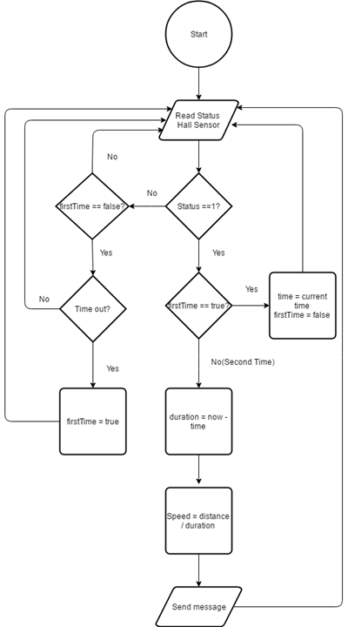

Figure 57: Interaction Diagram – [Train]Sending Message Process with train’s speed.

**Summary:** This diagram shows the process when the train receives messages in specific situation and try to warning driver to deal with it.

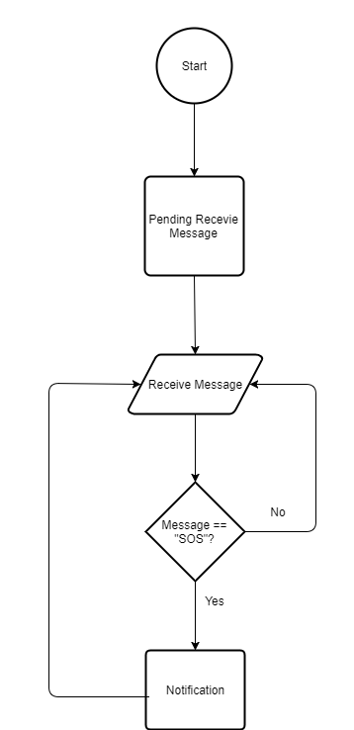

Figure 58: Interaction Diagram – [Train]Notification Process

##### 4.2.3.2 Control unit process

**Summary:** This diagram shows the process when the station receives warning messages from train coming and do function for people and vehicles crossing railways carefully.

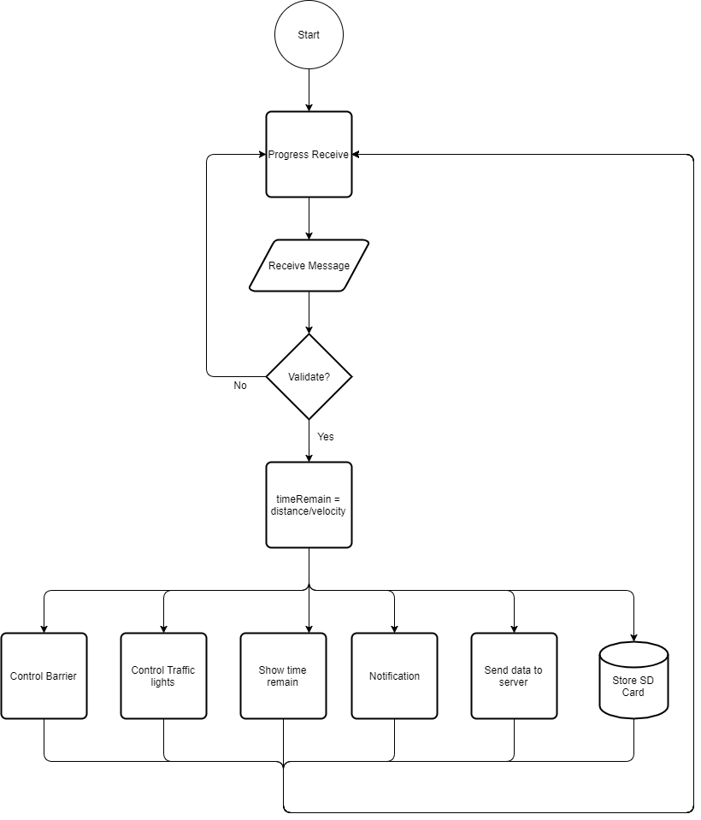

Figure 59:Interaction Diagram – [Control]Notification Process

**Summary:** This diagram shows the process when the station receives warning messages from train coming and train will handle process, try to warning driver to deal with it

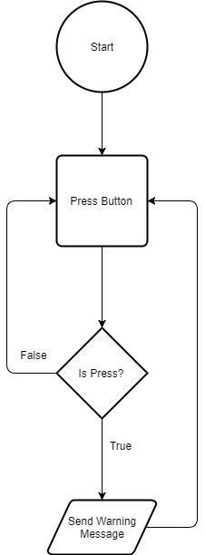

Figure 60: Interaction Diagram – [Station] Sending Obstacle warning to train

### 4.2 Hardware Detailed Description

#### 4.2.1 Arduino Mega 2560

* **Overview**
* The Arduino Mega 2560 is a microcontroller board based on the ATmega2560. It has 54 digital input/output pins (of which 15 can be used as PWM outputs), 16 analog inputs, 4 UARTs (hardware serial ports), a 16 MHz crystal oscillator, a USB connection, a power jack, an ICSP header, and a reset button. It contains everything needed to support the microcontroller; simply connect it to a computer with a USB cable or power it with a AC-to-DC adapter or battery to get started. The Mega 2560 board is compatible with most shields designed for the Uno and the former boards Duemilanove or Diecimila.

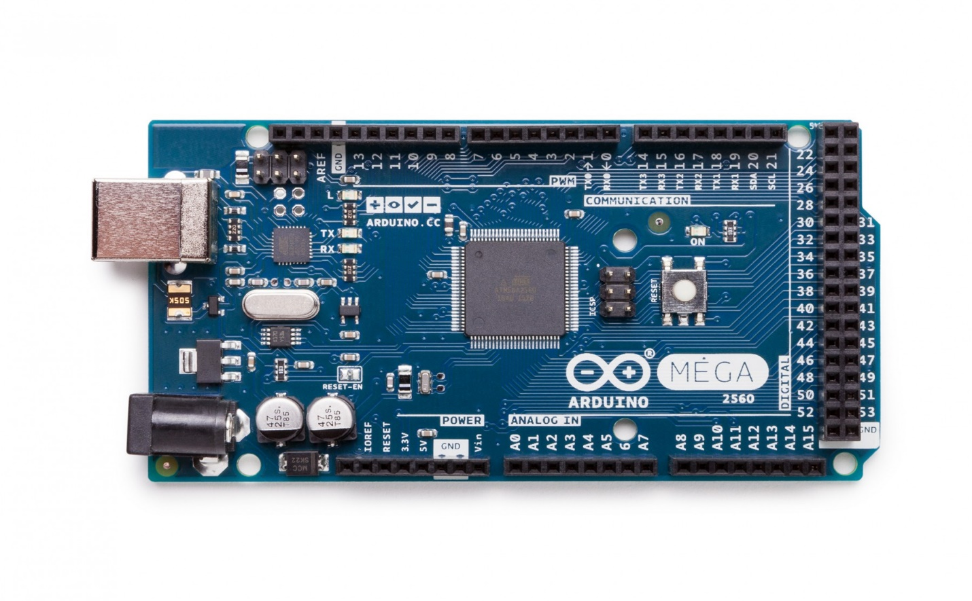

Figure 61: Arduino Mega 2560

* **Document**

Arduino Mega 2560 PIN mapping table (reference at: <https://www.arduino.cc/en/Hacking/PinMapping2560>)

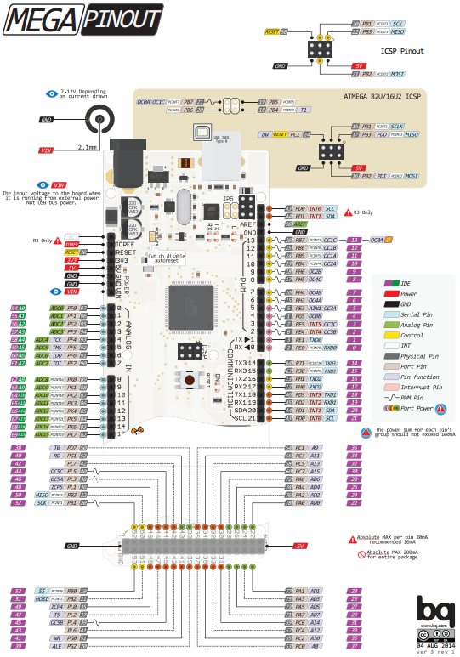

Figure 62: Pin out diagram Mega 2560

#### 4.2.2 Arduino Mini

* **Overview**
* The Arduino Pro Mini is a microcontroller board based on the ATmega328.
* It has 14 digital input/output pins (of which 6 can be used as PWM outputs), 6 analog inputs, an on-board resonator, a reset button, and holes for mounting pin headers. A six pins header can be connected to an FTDI cable or Sparkfun breakout board to provide USB power and communication to the board.
* The Arduino Pro Mini is intended for semi-permanent installation in objects or exhibitions. The board comes without pre-mounted headers, allowing the use of various types of connectors or direct soldering of wires. The pin layout is compatible with the Arduino Mini.
* There are two version of the Pro Mini. One runs at 3.3V and 8 MHz, the other at 5V and 16 MHz.
* The Arduino Pro Mini was designed and is manufactured by SparkFun Electronics.

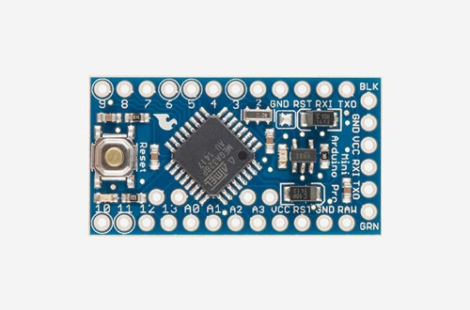

Figure 63: Arduino Pro Mini

* **Document**

Datasheet (reference at: https://www.engineersgarage.com/sites/default/files/Datasheet.rar)

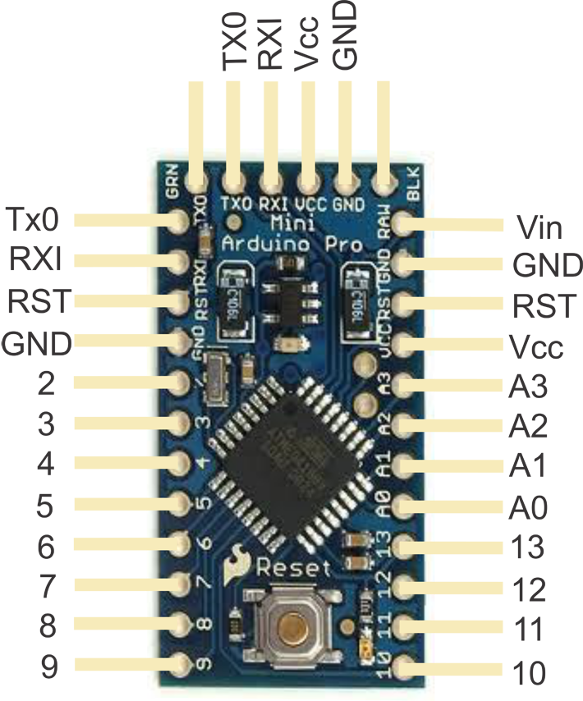

Figure 64: Pin out diagram’s Arduino Mini

#### 4.2.3 ESP8266 Node MCU

* **Overview**
* This WiFi Internet of Things (IOT) module is compatible with Arduino IDE. ESP8266 Node MCU is high integration wireless SOCs, designed for space and power constrained mobile platform designers. It provides unsurpassed ability to embed Wi-Fi capabilities within other systems, or to function as a standalone application, with the lowest cost, and minimal space requirement.



Figure 65: ESP8266 nodeMCU

* **Pin out diagram**

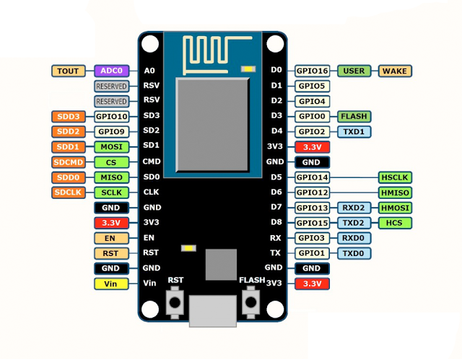

*Figure 49: PIN of* ***ESP8266 nodeMCU***

#### 4.2.4 Seven-Segment LED Display

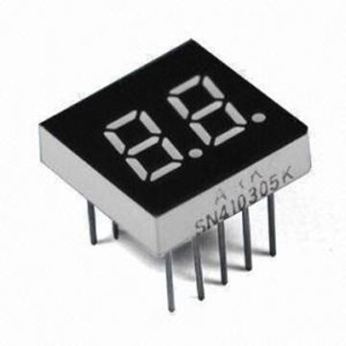

Figure 66: Seven-Segment LED Display

* For demo, we use our custom created seven-segment display led for main gate display board.

The led in the main gate display board displays the time remaining to warn people pay more attention to a train is coming.

#### 4.2.5 Magnetic Sensor (Hall Sensor)



Figure 67: Hall sensor

* **Hall effect**
* The Hall effect is the production of a voltage difference (the Hall voltage) across an electrical conductor, transverse to an electric current in the conductor and to an applied magnetic field perpendicular to the current.

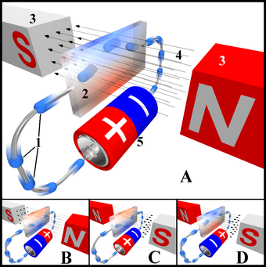

Figure 68: Hall effect

#### 4.2.6 LED

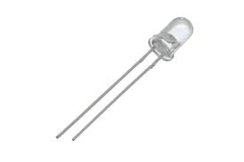

Figure 69: LED

* A light-emitting diode (LED) is a two-[lead](https://en.wikipedia.org/wiki/Lead_(electronics)) [semiconductor](https://en.wikipedia.org/wiki/Semiconductor) [light source](https://en.wikipedia.org/wiki/Light_source). It is a [p–n junction](https://en.wikipedia.org/wiki/P%E2%80%93n_junction) [diode](https://en.wikipedia.org/wiki/Diode) that emits light when activated.[[5]](https://en.wikipedia.org/wiki/Light-emitting_diode#cite_note-5) When a suitable [voltage](https://en.wikipedia.org/wiki/Voltage) is applied to the leads, [electrons](https://en.wikipedia.org/wiki/Electron) are able to recombine with [electron holes](https://en.wikipedia.org/wiki/Electron_hole) within the device, releasing energy in the form of [photons](https://en.wikipedia.org/wiki/Photon). This effect is called [electroluminescence](https://en.wikipedia.org/wiki/Electroluminescence), and the color of the light (corresponding to the energy of the photon) is determined by the energy [band gap](https://en.wikipedia.org/wiki/Band_gap) of the semiconductor.
* 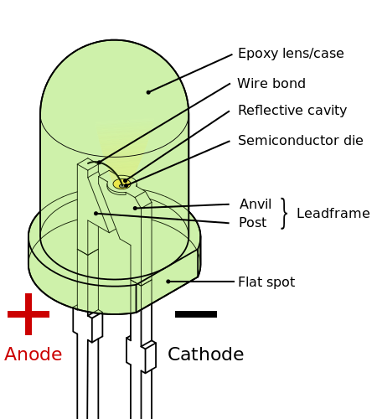

Figure 70 LED construct

**IMPLEMENT:** Because the base Volt of LED is small (between 1.9 ~ 3.2 volt) and Arduino pin output is 5 Volt. Therefore, when using a Led you must decrease the Volt of Arduino pin. We connect to Anode to the pin 13 with a resistor (220 ~ 1000 Ohm) depend on the base Volt of LED, and Cathode to ground.

More detail about led project: https://www.arduino.cc/en/Tutorial/Blink

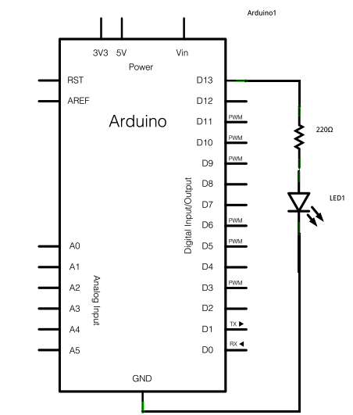

Figure 71: A LED demo from Arduino.com

#### 4.2.7 RF Module

The RF module, as the name suggests, operates at Radio Frequency. The corresponding frequency range varies between 30 kHz & 300 GHz. In this RF system, the digital data is represented as variations in the amplitude of carrier wave.

This wireless transmitter and receiver pair operate at 315Mhz. They can easily fit into a breadboard and work well with microcontrollers to create a very simple wireless data link.

**Note:** These modules are indiscriminate and will receive a fair amount of noise. Both the transmitter and receiver work at common frequencies and don’t have IDs. Therefore, a method of filtering this noise and pairing transmitter and receiver will be necessary.

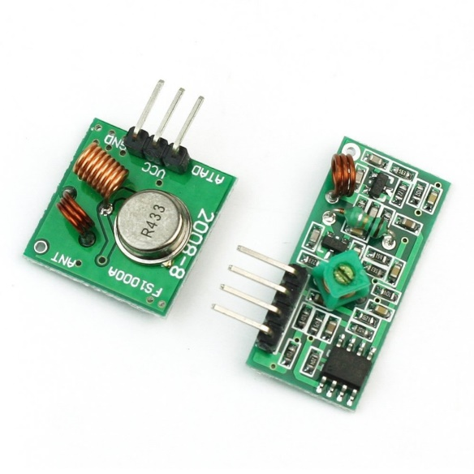

Figure 72: RF Module

**Receiver Module**

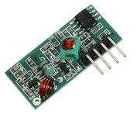

Figure 73: RF Receive MX-05V Module

1. Product Model: MX-05V  
2. Operating voltage: DC5V  
3. Quiescent Current: 4mA  
4. Receiving frequency: 315Mhz  
5. Receiver sensitivity: -105DB  
6. Size: 30 * 14 * 7mm

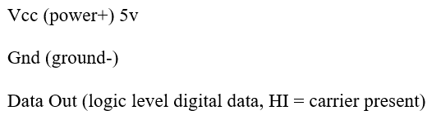

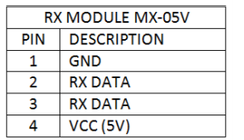

Figure 74: RF Receive MX-05V Pin Module

**Transmitter Module**

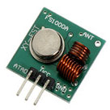

Figure 75: RF Transmitter MX-FS-03V Module

1. Product Model: MX-FS-03V  
2. Launch distance :20-200 meters (different voltage, different results)  
3. Operating voltage :3.5-12V  
4. Dimensions: 19 * 19mm  
5. Operating mode: AM  
6. Transfer rate: 4KB / S  
7. Transmitting power: 10mW  
8. Transmitting frequency: 315Mhz  
9. An external antenna: 25cm ordinary multi-core or single-core line  
10. Pinout from left to right: (DATA; VCC; GND)

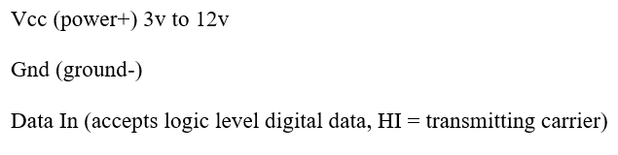

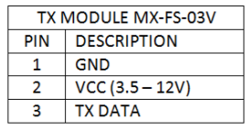

Figure 76: RF Transmitter MX-FS-03V Module

**How 3-pin RF Module Works and Implement**

When the transmitter data pin is LO, the transmitter is off, and draws less than 1uA. (Mine drew 200 mA from the 5v supply when off). When the transmitter data pin is HI, it is transmitting solid 433 or 315 MHz carrier wave, and with a 5v supply transmitter drew about 12mA when transmitting continuous carrier.

The receiver (when powered up) will crank up its gain until it starts to receive something. If no transmitter is working, the receiver will receive some static. If a modulated carrier (a carrier wave which is turning on and off) is received, the receiver will reduce its gain to remove lesser signals, and ideally will then output the same modulated digital data as that which is controlling the transmitter.

It's important to know that the receiver takes a bit of time to adjust its gain, so any "packet" of data transmitted should start with a "preamble" before the main data and the receiver will then have time to self-adjust its gain before the important data starts.

* For Receiver Module

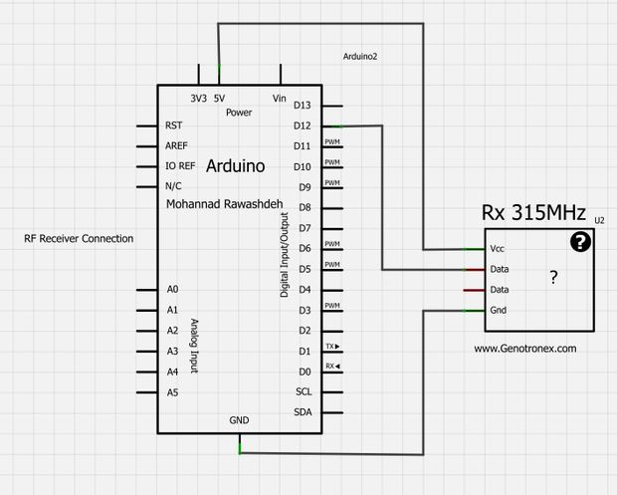

Figure 77: RF Receive MX-05V Pin Module

* 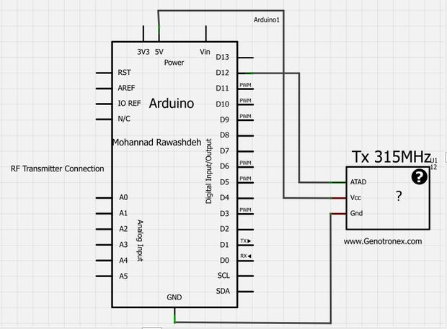For Transmitter Module

Figure 78: RF Transmitter MX-FS-03V Module

#### 4.2.8 Real Time (RTC DS1307)

**DESCRIPTION**

The DS1307 is a low-cost, extremely accurate I²C real-time clock (RTC) with an integrated temperature-compensated crystal oscillator (TCXO) and crystal. The device incorporates a battery input, and maintains accurate timekeeping when main power to the device is interrupted. The integration of the crystal resonator enhances the long-term accuracy of the device as well as reduces the piece-part count in a manufacturing line. The DS1307 is available in commercial and industrial temperature ranges, and is offered in a 16-pin, 300-mil SO package.

The RTC maintains seconds, minutes, hours, day, date, month, and year information. The date at the end of the month is automatically adjusted for months with fewer than 31 days, including corrections for leap year. The clock operates in either the 24-hour or 12-hour format with an active-low AM/PM indicator.

Figure 79: RTC DS1307

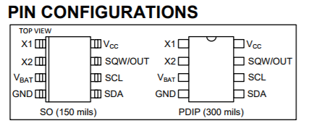

Figure 80: RTC DS1307 PIN Configuration

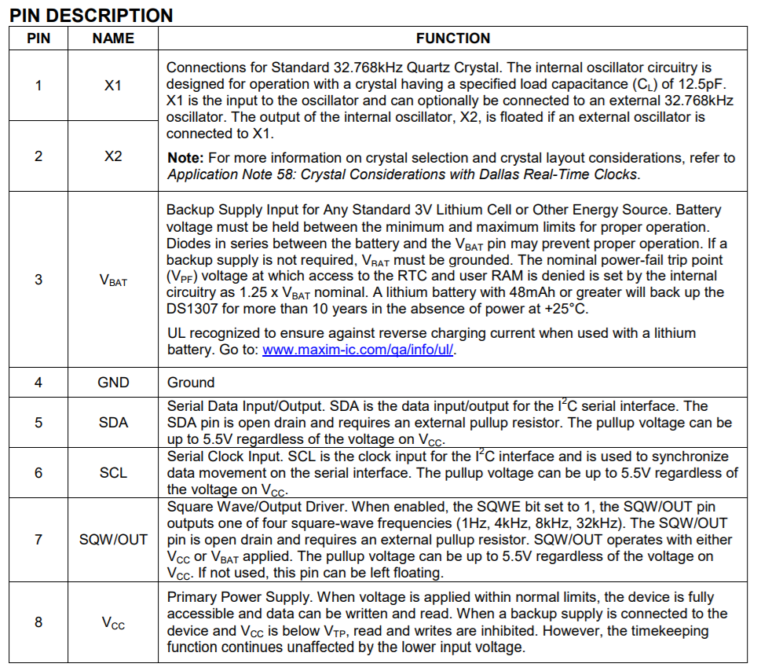

Figure 81: RTC DS1307 PIN Description

### 4.3 Software Program Detailed Description

#### 4.3.1 Class Diagram

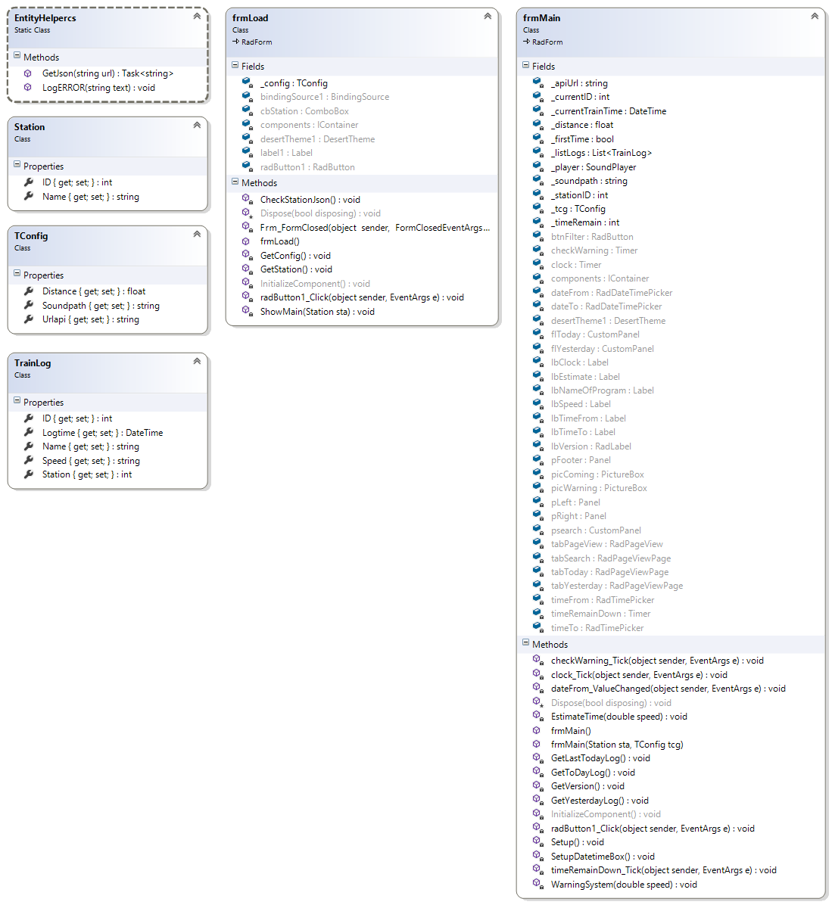Figure 82 Software Class Diagram

#### 4.3.2 Class Diagram Explanation

##### 4.3.2.1 Entity Helper Class (Static Class)

* **Attributes**
* N/A
* **Methods**

|  |  |  |  |
| --- | --- | --- | --- |
| **Method** | **Return Type** | **Visibility** | **Description** |
| GetJson | Task<string> | Public | Return JSON result from API |
| LogERROR | void | Public | Log error of system |

Table 38: Entity Helper Class Methods

##### 4.3.2.2 Station Class

* **Attributes**

|  |  |  |  |
| --- | --- | --- | --- |
| **Attribute** | **Type** | **Visibility** | **Description** |
| Id | Int | Public | Contains id of Entity Model (Station) |
| Name | String | Public | Contains Name of Entity Model (Station) |

Table 39: Station Class Attributes

* **Methods**
* N/A

##### 4.3.2.3 Tconfig Class

* **Attribute**

|  |  |  |  |
| --- | --- | --- | --- |
| **Attribute** | **Type** | **Visibility** | **Description** |
| Distance | Float | Public | Contains distance get from config.json |
| Soundpath | String | Public | Contains soundpath get from config.json |
| Urlapi | String | Public | Contains urlapi get from config.json |

Table 40: Tconfig Class Attributes

* **Methods**
* N/A

##### 4.3.2.4 Trainlog Class

* **Attributes**

|  |  |  |  |
| --- | --- | --- | --- |
| **Attribute** | **Type** | **Visibility** | **Description** |
| Id | Float | Public | Contains id of Entity Model (TrainLog) |
| Logtime | Datetime | Public | Contains logtime of Entity Model (TrainLog) |
| Name | String | Public | Contains name of Entity Model (TrainLog) |
| Speed | String | Public | Contains speed of Entity Model (TrainLog) |
| Station | Int | Public | Contains station of Entity Model (TrainLog) |

Table 41: Trainlog Class Attributes

* **Methods**
* N/A

##### 4.3.2.5 frmMain Class

* **Fields**

|  |  |  |  |
| --- | --- | --- | --- |
| **Field** | **Type** | **Visibility** | **Description** |
| _apiUrl | String | Private | Contains attribute when get file config.json |
| _currentID | Int | Private | Contains current station after user load main application |
| _currentTrainTime | Int | Private | Flag variable to check coutdown |
| _distance | Datetime | Private | Contains attribute when get file config.json |
| _firstTime | Bool | Private | Flag variable to check business logic |
| _listLogs | List<TrainLog> | Private | Contains data LOG when get json data |
| _player | SoundPlayer | Private | Contains attribute when get file config.json |
| _soundpath | String | Private | Contains attribute when get file config.json |
| _stationID | Int | Private | Contains attribute to check duplicated station id |
| _tcg | Tconfig | Private | Contains variable config when load main application |
| _timeRemain | Int | Private | Time countdown |
| btnFilter | RadButton | Private | Component button |
| checkWarning | Timer | Private | Component Timer to request JSON every 800 milliseconds |
| clock | Timer | Private | Component Timer to build clock system |
| components | IContainer | Private | Required desinger variable |
| dateFrom | RadDateTimePicker | Private | Component Rad Date Time Picker helps user pick date |
| dateTo | RadDateTimePicker | Private | Component Rad Date Time Picker helps user pick date |
| desertTheme1 | DesertTheme | Private | Required designer variable |
| flToday | CustomPanel | Private | Use to allways show vertical scroll on panel |
| flYesterday | CustomPanel | Private | Use to allways show vertical scroll on panel |
| lbClock | Label | Private | Windows label component |
| lbEstimate | Label | Private | Windows label component |
| lbnameOfProgram | Label | Private | Windows label component |
| lbSpeed | Label | Private | Windows label component |
| lbTimeFrom | Label | Private | Windows label component |
| lbTimeTo | Label | Private | Windows label component |
| lbVersion | Label | Private | Windows label component |
| pFooter | Label | Private | Windows label component |
| picComing | PictureBox | Private | Contains picture train coming |
| picWarnning | PictureBox | Private | Contains picture warning |
| pLeft | Panel | Private | Dock left layout for winform |
| pRight | Panel | Private | Dock right layout for winform |
| pSearch | CustomPanel | Private | Use to allways show vertical scroll on panel |
| tabPageView | RadPageView | Private | Tab layout component |
| tabSearch | RadPageViewPage | Private | Tab layout component |
| tabToday | RadPageViewPage | Private | Tab layout component |
| tabYesterday | RadPageViewPage | Private | Tab layout component |
| timeFrom | RadTimePicker | Private | Component Rad Time Picker helps user pick time |
| timeRemainDown | Timer |  | Component Timer to countdown time remain |
| timeTo | RadTimePicker | Private Private | Component Rad Time Picker helps user pick time |

Table 42 frmMain Class Attributes

* **Methods**

|  |  |  |  |
| --- | --- | --- | --- |
| **Method** | **Return Type** | **Visibility** | **Description** |
| Dispose | void | Protected | Clean up any resources being used |
| InitializeComponents | void | Private | Required method for desinger support |
| checkWarning_Tick | void | Private | Handle timer event to request JSON |
| clock_Tick | void | Private | Handle timer event to build clock system |
| dateFrom_ValueChanged | void | Private | Handle after changed value of dateFrom to eheck validation |
| EstimateTime | void | Private | Process remain time |
| frmMain() |  | Public | Contructor default |
| frmMain() |  | Public | Contructor with parameter |
| GetLastTodayLog | void | Private | Function to get last today log |
| GetTodayLog | void | Private | Function to get today log |
| GetYesterdayLog | void | Private | Function to get yesterday log |
| radButton1_Click | void | Private | Handle radbutton1 clicked for filtering data log |
| Setup | void | Private | Default configuration for system |
| SetupDatetimeBox | void | Private | Set default value for datatime picker |
| timeRemainDown_Tick | void | Private | Handle timer event to count down remain |
| WarningSystem | void | Private | Progress core warning system |

Table 43: frmMain Class Methods

##### 4.3.2.6 frmLoad Class

* **Fields**

|  |  |  |  |
| --- | --- | --- | --- |
| **Field** | **Type** | **Visibility** | **Description** |
| _config | TConfig | Private | Contains variable of config.json |
| bindingSource1 | BindingSource | Private | Use to parse List<> to Datasource |
| cbStation | Combobox | Private | Component combo box |
| desertTheme1 | DesertTheme | Private | Required designer variable |
| label1 | Label | Private | Component label |
| radButton1 | RadButton | Private | Component button |

Table 44: frmLoad Class Fields

* **Methods**

|  |  |  |  |
| --- | --- | --- | --- |
| **Method** | **Return Type** | **Visibility** | **Description** |
| CheckStationJson | void | Private | Check current station in system |
| Dispose | void | Protected | Clean up any resources being used |
| Frm_FromClosed | void | Private | Handle form closed event |
| formLoad() | void | Public | Handle load form event |
| GetConfig() | void | Private | Get file config.json |
| GetStation | void | Private | Get data station use API |
| InitializeComponents | void | Private | Required method for desinger support |
| radButton1_Click | void | Private | Handle radbutton1 clicked |
| ShowMain() | void | Private | Show frmMain() application |

Table 45: frmLoad Class Methods

## Interface

### 5.1 Component interface design

#### 5.1.1 Station Interface design

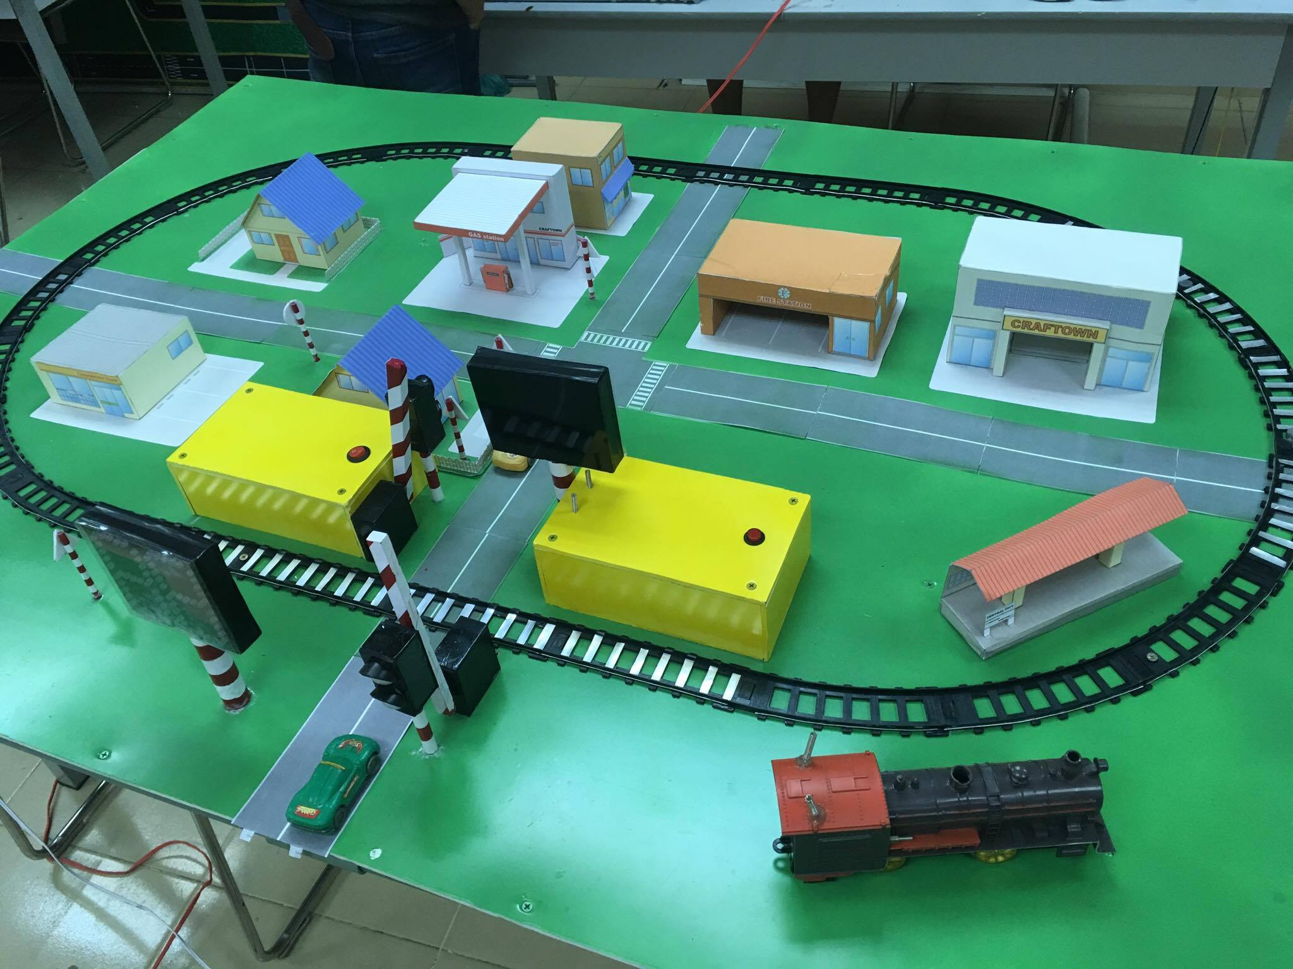

Figure 83: [Component] Station Interface design

**Description**

|  |  |  |  |
| --- | --- | --- | --- |
| No | Module | Description | Validation |
| 1 | Seven-segment display | Show time remain | Show number from 00 to 99 |
| 2 | Barrier | Prevent driver go to railway | Low down and put up |
| 3 | Traffic lights | Control traffic | Turn on/off Red light Turn on/off Yellow light |
| 4 | Control box | Content control module | N/A |

Table 46: [Component] Station Interface description

#### 5.1.2 Controller Interface design

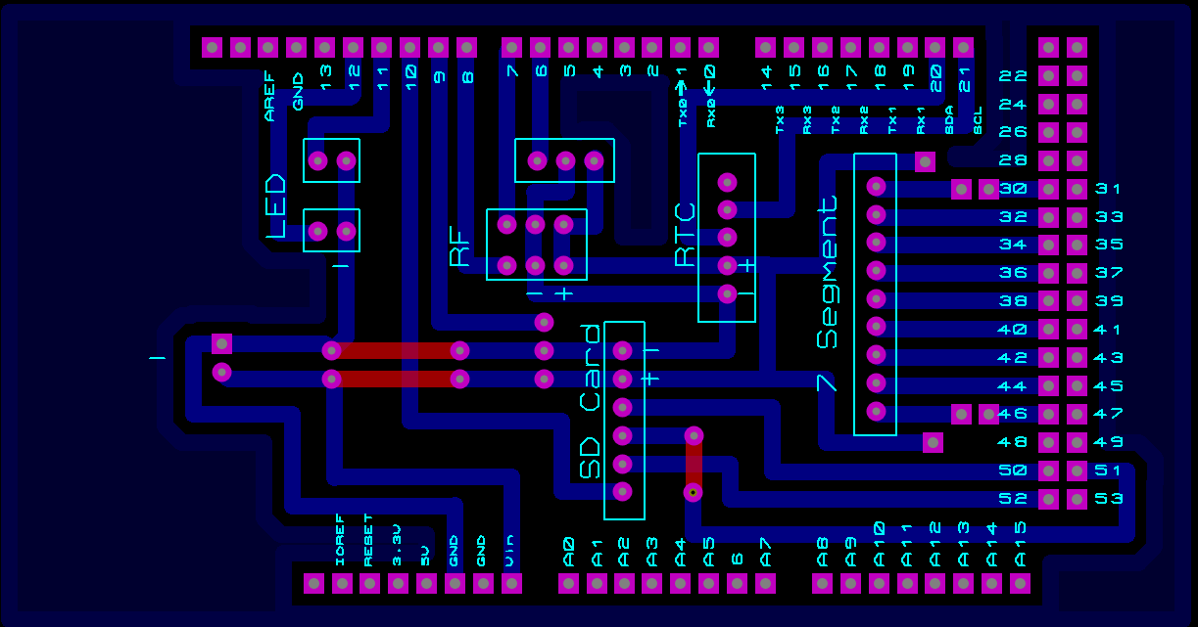

Figure 84: [Component] Controller Interface design

**Description**

|  |  |  |  |
| --- | --- | --- | --- |
| No | Module | Description | Validation |
| 1 | Micro SD card | Logging data | N/A |
| 2 | Module RTC DS1307 | Current time | Current time |
| 3 | Arduino Mega 2560 | Controller | N/A |
| 4 | Shield | Connection module | N/A |
| 5 | Module ESP8266 nodeMCU | Wifi module | N/A |
| 6 | Wire | Connection module | N/A |

Table 47: [Component] Controller Interface description

### 5.2 Software interface design

#### 5.2.1 Select station interface design

Figure 85: [Software] Station interface design

**Fields**

|  |  |  |  |  |  |  |
| --- | --- | --- | --- | --- | --- | --- |
| ***No*** | ***Fields name*** | ***Description*** | ***Read Only*** | ***Mandatory*** | ***Data type*** | ***Length*** |
| 1 | Station | Name of station | Yes | Yes | String | N/A |

Table 48: Field of Select Station

**Button**

|  |  |  |  |  |
| --- | --- | --- | --- | --- |
| ***No*** | ***Function*** | ***Description*** | ***Validation*** | ***Outcome*** |
| 1 | Load data | Choose the station to receive data | N/A | Train Warning System |

Table 49: Button of Select Station

#### 5.2.2 Train Warning System interface design

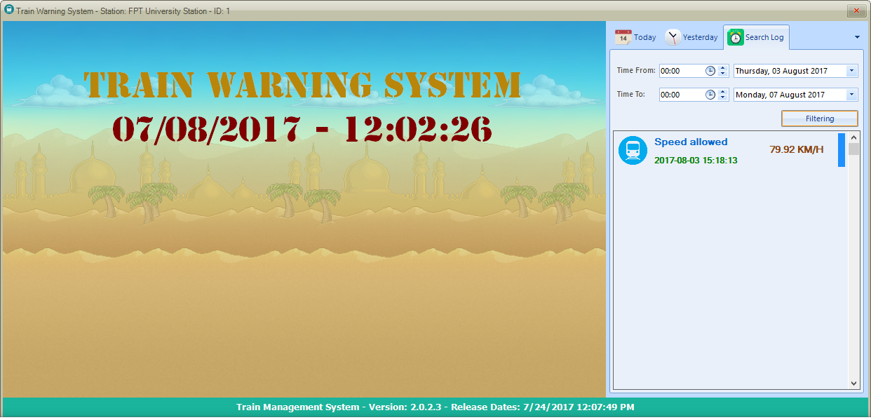

Figure 86: Train Warning System interface design

**Fields**

|  |  |  |  |  |  |  |
| --- | --- | --- | --- | --- | --- | --- |
| ***No*** | ***Fields name*** | ***Description*** | ***Read Only*** | ***Mandatory*** | ***Data type*** | ***Length*** |
| 1 | Time From | Time begin want to search | No | Yes | Date time | N/A |
| 2 | Time To | Time end want to search | No | Yes | Date time | N/A |

Table 50: Fields of Train Warning System

**Button**

|  |  |  |  |  |
| --- | --- | --- | --- | --- |
| ***No*** | ***Function*** | ***Description*** | ***Validation*** | ***Outcome*** |
| 1 | Load data | Choose the station to receive data | N/A | Train Warning System |

## Algorithms

* Algorithms calculation speed
  + The train runs through two magnets, we can get duration time between two magnets. Base on duration time and distance of two magnets we use recipe calculation velocity:

$v=\frac{S}{t}$

V: velocity

S: Distance

t: duration

* Algorithms calculation time remain
  + The station receive message and have speed of the train, It will calculation time when the train go to station for notification to driver. Base on speed of the train and distance of the last magnet to the station.

V: velocity

S: Distance

t: duration

$t=\frac{S}{v}$

# System Implementation & Test

## Introduction

### 1.1 Overview

* This section has all necessary information about test plan, test case and its result, the environment for testing and test pass/fail criteria

### 1.2 Test Approach

* White-box: Developers self-test on code in which function they developed
* In this section, Black-box testing will be used to test whether the whole system meets the following objectives.

## Database Relationship Diagram

### 2.1 Physical Diagram

Figure 87: Database Relationship Diagram

### 2.2 Data Dictionary

|  |  |  |  |  |  |
| --- | --- | --- | --- | --- | --- |
| **trainlog** | | | | | |
| **P/F** | **Field Name** | **Caption** | **Data Type** | **Field Size** | **Note** |
| P | Id | Id | Int | 11 | Autonumber |
|  | speed | Speed | Varchar | 255 |  |
|  | logtime | Log Time | Datetime |  | Timestamp |
| F | stationid | Station Id | Int | 11 |  |

Table 51: Train log

|  |  |  |  |  |  |
| --- | --- | --- | --- | --- | --- |
| **station** | | | | | |
| **P/F** | **Field Name** | **Caption** | **Data Type** | **Field Size** | **Note** |
| P | Id | Id | Int | 11 | Autonumber |
|  | Name | Station Name | Varchar | 255 |  |

Table 52: Station

## Performance Measures

The most important of our system is RF Module. We use RF 315 Mhz. Another component is ESP8266 Node MCU, use 2,4 Ghz. We choose test component from all condition:

* Test environment: we choose test in public because lots of electronic devices can be interference of frenquency Radio Frequency signal.

## Test plan

### 4.1 Features to be tested

#### 4.1.1 Hardware

|  |  |
| --- | --- |
| Functions | Description |
| Arduino Mega 2560 | Test all GPIO between Mega and RF Module 315 Mhz, if can receive and transfer data, test case: “passed”, otherwise is “failed” |
| Arduino Pro Mini | Test all GPIO between Pro Mini and Hall Sensor Module, if can detect magnet under railway, test case: “passed”, otherwise is “failed” |
| Hall Sensor Module | Detect magnet under railway and send signal to Arduino, indoor, outdoor, real environment, some in at time in day  Test range of active, obstacle between Sensor and Magnet  After many tests, estimate value of Hall Sensor  If device detect successfully, result: “passed”, device can detect: “failed” |
| RF Module 315 Mhz | RF communicate:  Test component by message packets to transfer and receive, Add new variable different size, test max range two component can communicate  Test TX: test send signal in complex environment: rain, sunny, obstacle between transmit device and receive device Test RX: test repeatedly until it fail to receive signal  If it send and receive successfully, result “passed”, otherwise “failed” |
| RTC DS1307 | Connect with Arduino, set default time, then show time by Serial Monitor. If it show exactly time, test case “passed”, if not, result “failed” |
| Mini SD Card Module | Connect with Arduino, read 1 file .txt and print in Serial Monitor. If print successful, device work well, “passed”, otherwise “failed” |
| Speaker | Connect GPIO with Arduino, speak 1 sound file in ROM. If Speaker sound successful, test case “passed”, if not “failed” |
| Buzzer | Set High signal by GPIO, if Buzzer sound, test case “passed”, otherwise “failed” |
| Barrier | Barrier slow down/ put up. |
| LED seven-segment display | Check LED ability show from 00 to 99 |
| LED indicator | Check volume of LED show |
| ESP8266 nodeMCU | Check connect wifi, check send data |

Table 53: Test plan hardware

#### 4.1.2 API

|  |  |
| --- | --- |
| Functions | Description |
| Get Station | Use postman and access link: “http://54.254.209.151 /train/api/getstation” |
| Get Log Today | Use postman and access link: “http://54.254.209.151/train/api/gettodaylog” |
| Get Log Yesterday | Use postman and access link: “http://54.254.209.151/train/api/getyesterdaylog” |
| Input Log data | Use postman and access link:  “http://54.254.209.151/train/api/index” |

Table 54: Test plan API

#### 4.1.3 Software

|  |  |
| --- | --- |
| Functions | Description |
| Application C# | Black-box testing on user interface |
| API Server | Service provide for Applications C#:  - Receive Speed   * Show in interface * Warning Train coming by visual * Warning Train coming by hearing * Show log data(Train pass railways) * Filter log by date |

Table 55: Test plan software

### 4.2 Features to be not tested

N/A

### 4.3 Test environment

Web server:

Operating System: Windows 10

Hardware:

### 4.4 Test Pass/Fail Criteria

## System Testing Test Case

### 5.1 Component Testing

|  |  |  |  |  |  |  |  |
| --- | --- | --- | --- | --- | --- | --- | --- |
| Id | Test Case Description | Test Case Procedure | Expected Output | Inter-test Case Dependency | Result | Test Date | Note |
| CT-01 | Hall Sensor Module detect Magnet in railways | Connect Hall Sensor module with Arduino Mega  Connect LED indicator with Mega  Take Magnet into Sensor (3cm) | LED show red | N/A | Passed | 1-8-2017 | N/A |
| CT-02 | Hall Sensor detect Magnet in railways | Connect Hall Sensor module with Arduino Mega  Connect LED indicator with Mega  Take Magnet into Sensor (10cm) | LED show red | N/A | Passed | 1-8-2017 | N/A |
| CT-03 | Hall Sensor detect Magnet in railways (out range) | Connect Hall Sensor module with Arduino Mega  Connect LED indicator with Mega  Take Magnet into Sensor (1m) | Nothing to show (out range of Hall Sensor) | N/A | Passed | 1-8-2017 | N/A |
| CT-04 | Hall Sensor detect Magnet in railways (not anything else) | Connect Hall Sensor module with Arduino Mega  Connect LED indicator with Mega  Take Plastic into Sensor | Nothing to show | N/A | Passed | 1-8-2017 | N/A |
| CT-05 | Hall Sensor detect Magnet in railways when rainy | Connect Hall Sensor module with Arduino Mega in rain  Connect LED indicator with Mega  Take Magnet into Sensor (10cm) | LED show red | N/A | Passed | 1-8-2017 | N/A |
| CT-06 | Hall Sensor detect Magnet in railways in anytime | Connect Hall Sensor module with Arduino Mega at midnight  Connect LED indicator with Mega  Take Magnet into Sensor (10cm) | LED show red | N/A | Passed | 1-8-2017 | N/A |
| CT-07 | Hall Sensor detect Magnet in railways with obstacle between | Connect Hall Sensor module with Arduino Mega  Connect LED indicator with Mega  Take Plastic between Sensor and Magnet | LED show red | N/A | Passed | 1-8-2017 | N/A |
| CT-08 | RF Module [RX] receive message successful | Connect RF Module [RX] with Arduino Mega  Connect Mega with computer and open Serial Monitor  Put RF Module [TX] (tested “passed”) send string “ATC_123” repeated (10m) | Serial Monitor show string “ATC_123” | N/A | Passed | 1-8-2017 | N/A |
| CT-09 | RF Module [RX] receive message successful | Connect RF Module [RX] with Arduino Mega  Connect Mega with computer and open Serial Monitor  Put RF Module [TX] (tested “passed”) send string “ATC_123” repeated (400m) | Serial Monitor show string “ATC_123” | N/A | Passed | 1-8-2017 | N/A |
| CT-10 | RF Module [RX] receive message successful(out range) | Connect RF Module [RX] with Arduino Mega  Connect Mega with computer and open Serial Monitor  Put RF Module [TX] (tested “passed”) send string “ATC_123” repeated (500m) | Nothing to Show | N/A | Passed | 1-8-2017 | N/A |
| CT-11 | RF Module [TX] send message successful | Connect RF Module [TX] with Arduino Mega  Send string “ATC_123”  Put RF Module [RX] (tested “passed”) and open Serial Monitor  (5m) | Serial Monitor show string “ATC_123” | N/A | Passed | 1-8-2017 | N/A |
| CT-12 | RF Module [TX] send message successful in rain | Connect RF Module [TX] with Arduino Mega in rain  Send string “ATC_123”  Put RF Module [RX] (tested “passed”) and open Serial Monitor  (400m) | Serial Monitor show string “ATC_123” | N/A | Passed | 1-8-2017 | N/A |
| CT-13 | RF Module [TX] send message successful with Obstacle (metal) between | Connect RF Module [TX] with Arduino Mega  Send string “ATC_123”  Put Magnet between RF Module [TX] and [RX] (tested “passed”) , open Serial Monitor  (400m) | Nothing to Show | N/A | Passed | 1-8-2017 | N/A |
| CT-14 | RF Module [TX] send message successful with Obstacle (plastic) between | Connect RF Module [TX] with Arduino Mega  Send string “ATC_123”  Put Plastic between RF Module [TX] and [RX] (tested “passed”) , open Serial Monitor  (400m) | Serial Monitor show string “ATC_123” | N/A | Passed | 1-8-2017 | N/A |
| CT-15 | RTC DS1307 save and run real time | Set Time (17, 43, 00, 2, 8, 7, 17) (11:22:00 Thu 1-82017)  Connect with Arduino Mega and open Serial Monitor | Time show equal real time | N/A | Passed | 1-8-2017 | N/A |
| CT-16 | Mini SD Card Module | Connect with Arduino Mega  Read file .txt  Open Serial Monitor | Data in file show by line | N/A | Passed | 1-8-2017 | N/A |
| CT-17 | Speaker | Connect GPIO with Arduino Mega  Set to speak “Cảnh báo tàu đang đến” which save in ROM | Speak: “Cảnh báo tàu đang đến” | N/A | Passed | 1-8-2017 | N/A |
| CT-18 | Buzzer | Connect GPIO with Arduino Mega  Set high signal (signal 1) | Sound “beep… beep…” | N/A | Passed | 1-8-2017 | N/A |
| CT-19 | Barrier up | Connect with Arduino  Set Barrier put up | Barrier put up | N/A | Passed | 1-8-2017 | N/A |
| CT-20 | Barrier down | Connect with Arduino  Set Barrier slow down | Barrier slow down | N/A | Passed | 1-8-2017 | N/A |
| CT-21 | LED seven-segment display | Connect with Arduino  Set code show digit 00 to 99 | Show 00 to 99 | N/A | Passed | 1-8-2017 | N/A |
| CT-22 | LED indicator | Connect GPIO with Arduino  Set high value (pulse 1) | LED red is show | N/A | Passed | 1-8-2017 | N/A |
| CT-23 | ESP8266 node MCU connect wifi | Connect GPIO with Arduino  Set ID:”404 – NETWORK NOT FOUND”  Password:”cccccccc” | Connect successfully | N/A | Passed | 1-8-2017 | N/A |
| CT-24 | ESP8266 node MCU connect server | Connect GPIO with Arduino  Set ID:”404 – NETWORK NOT FOUND”  Password:”abcd” | Connect fail | N/A | Passed | 1-8-2017 | N/A |
| CT-25 | ESP8266 node MCU connect server | Connect GPIO with Arduino  Set ID:”404 – NETWORK”  Password:”cccccccc” | Connect fail | N/A | Passed | 1-8-2017 | N/A |
| CT-26 | ESP8266 node MCU connect server | Connect GPIO with Arduino  Set ID:”404 – NETWORK”  Password:”abcd” | Connect fail | N/A | Passed | 1-8-2017 | N/A |
| CT-27 | ESP8266 node MCU connect server | Connect to Server:  “~/54.254.209.151/~” | Connect successfully | N/A | Passed | 1-8-2017 | N/A |
| CT-28 | ESP8266 node MCU connect server | Connect to Server:  “~/54.111.111.11/~” | Connect fail | N/A | Passed | 1-8-2017 | N/A |

Table 56: Component Test Case

### 5.2 API Web Service Testing

|  |  |  |  |  |  |  |  |
| --- | --- | --- | --- | --- | --- | --- | --- |
| Id | Test Case Description | Test Case Procedure | Expected Output | Inter-test Case Dependency | Result | Test Date | Note |
| AT-01 | Get Station | Access API link: “~/train/api/getstation” | Json result: [{"id":1,"name":"FPT University Station"},{"id":2,"name":"Saigon Station"}] | N/A | Passed | 2-8-2017 | N/A |
| AT-02 | Get Today Log | Access API link: “~/train/api/gettodaylog” with parameter “id=1” | Json result: All log in today | N/A | Passed | 2-8-2017 | N/A |
| AT-03 | Get Today Log | Access API link: “~/train/api/gettodaylog” with parameter “id=9999” | Json result: [] | N/A | Passed | 2-8-2017 | N/A |
| AT-04 | Get Today Log | Access API link: “~/train/api/gettodaylog” with parameter “id=abcd” | Json result: [] | N/A | Passed | 2-8-2017 | N/A |
| AT-05 | Get Yesterday Log | Access API link: “~/train/api/getyesterdaylog” with parameter “id=1” | Json result: All log in today | N/A | Passed | 2-8-2017 | N/A |
| AT-06 | Get Yesterday Log | Access API link: “~/train/api/getyesterdaylog” with parameter “id=9999” | Json result: [] | N/A | Passed | 2-8-2017 | N/A |
| AT-07 | Get Yesterday Log | Access API link: “~/train/api/getyesterdaylog” with parameter “id=abcd” | Json result: [] | N/A | Passed | 2-8-2017 | N/A |
| AT-08 | Log data | Access API link: “~/train/api/index” with parameter “id=1” and “speed=0.15” | Json result: {"status":200,"message":"successed"} | N/A | Passed | 2-8-2017 | N/A |
| AT-09 | Log data | Access API link: “~/train/api/index” with parameter “id=1” and “speed= -0.15” | Json result: {"status":200,"message":"successed"} | N/A | Passed | 2-8-2017 | N/A |
| AT-10 | Log data | Access API link: “~/train/api/index” with parameter “id=1” and “speed=abcd” | Blank page | N/A | Passed | 2-8-2017 | N/A |
| AT-11 | Log data | Access API link: “~/train/api/index” with parameter “id=9999” and “speed=0.15” | Json result: {"status":200,"message":"successed"} | N/A | Passed | 2-8-2017 | N/A |
| AT-12 | Log data | Access API link: “~/train/api/index” with parameter “id=9999” and “speed= -0.15” | Json result: {"status":200,"message":"successed"} | N/A | Passed | 2-8-2017 | N/A |
| AT-13 | Log data | Access API link: “~/train/api/index” with parameter “id=9999” and “speed= abcd” | Blank page | N/A | Passed | 2-8-2017 | N/A |
| AT-14 | Log data | Access API link: “~/train/api/index” with parameter “id=abcd” and “speed=0.15” | Json result: {"status":200,"message":"successed"} | N/A | Passed | 2-8-2017 | N/A |
| AT-15 | Log data | Access API link: “~/train/api/index” with parameter “id=abcd” and “speed= -0.15” | Json result: {"status":200,"message":"successed"} | N/A | Passed | 2-8-2017 | N/A |
| AT-16 | Log data | Access API link: “~/train/api/index” with parameter “id=abcd” and “speed=abcd” | Blank page | N/A | Passed | 2-8-2017 | N/A |

Table 57: API Test Case

### 5.3 Integration Testing

|  |  |  |  |  |  |  |  |
| --- | --- | --- | --- | --- | --- | --- | --- |
| Id | Test Case Description | Test Case Procedure | Expected Output | Inter-test Case Dependency | Result | Test Date | Note |
| IT-01 | LED 7-segment show second when train in range 400m(*) | Put train run in railways  When train pass the second Magnet, warning signal send to Station | LED 7-segment show time(second) from 2nd Magnet to barrier | N/A | Passed | 3-8-2017 | N/A |
| IT-02 | LED 7-segment off when train pass over barrier | Put train run in railways  When train pass over barrier, all of warning off | LED 7-segment off | N/A | Passed | 3-8-2017 | N/A |
| IT-03 | Traffic light show when train in range 400m(*), and Speed below 96km/h (*) | Put train run in railways, Speed below 96km/h (*)  When train pass the second Magnet, warning signal send to Station | Traffic light show yellow | N/A | Passed | 3-8-2017 | N/A |
| IT-04 | Traffic light show when train in range 400m(*), and Speed over 96km/h (*) | Put train run in railways, Speed over 96km/h (*)  When train pass the second Magnet, warning signal send to Station | Traffic light show red | N/A | Passed | 3-8-2017 | N/A |
| IT-05 | Traffic light change color when train in range 400m(*), | Put train run in railways, Speed below 96km/h (*)  When train pass the second Magnet, warning signal send to Station | Traffic light show yellow, when only 15 seconds from train to barrier, traffic light change red | N/A | Passed | 3-8-2017 | N/A |
| IT-06 | Traffic light off when train pass over barrier | Put train run in railways  When train pass over barrier, all of warning off | Traffic light off | N/A | Passed | 3-8-2017 | N/A |
| IT-07 | Speaker speak when train in range 400m(*), | Put train run in railways  When train pass the second Magnet, warning signal send to Station | Speaker speak: “Cảnh báo tàu đang đến” until train pass over barrier | N/A | Passed | 3-8-2017 | N/A |
| IT-08 | Speaker off when train pass over barrier | Put train run in railways  When train pass over barrier, all of warning off | Speaker off | N/A | Passed | 3-8-2017 | N/A |
| IT-09 | System warning only work in range 400m(*) | Put train run in railways  When train not pass the first Magnet | Nothing happen | N/A | Passed | 3-8-2017 | N/A |
| IT-10 | System warning only work in range 400m(*) | Put train run in railways  When train passed the first Magnet but not passed the second Magnet | Nothing happen | N/A | Passed | 3-8-2017 | N/A |
| IT-11 | System warning only work if there is electric | Put train run in railways  When train passed the second Magnet  Turn off supply power | Nothing happen | N/A | Passed | 3-8-2017 | N/A |
| IT-12 | Button emergency work | Put train run in railways  When train not pass the first Magnet  Press button | Speaker speak and LED red show in Train | N/A | Passed | 3-8-2017 | N/A |
| IT-13 | Warning in train turn off if press button off | Put train run in railways  When train not pass the first Magnet  Press button off | Nothing happen | N/A | Passed | 3-8-2017 | N/A |
| IT-14 | Button emergency not work | Put train run in railways  When train passed the first Magnet but not passed the second Magnet Press button | Nothing happen | N/A | Passed | 3-8-2017 | N/A |
| IT-15 | Button emergency not work | Put train run in railways  When train passed second Magnet  Press button | Nothing happen | N/A | Passed | 3-8-2017 | N/A |
| IT-16 | Software warning when train in range 400m(*) | Put train run in railways  When train pass the second Magnet, warning signal send to Station | Software warning Train coming and show speed of train | N/A | Passed | 3-8-2017 | N/A |
| IT-17 | Software turn off warning when train passed Station | Put train run in railways  When train pass Station, warning turn off | Software turn off warning and save to Log data | N/A | Passed | 3-8-2017 | N/A |

Table 58: Integration Test Case

### 5.4 Software Testing

|  |  |  |  |  |  |  |  |
| --- | --- | --- | --- | --- | --- | --- | --- |
| Id | Test Case Description | Test Case Procedure | Expected Output | Inter-test Case Dependency | Result | Test Date | Note |
| ST-01 | Standby mode | Open Software | String: “Tran Warning System” and time of current system in Main Screen | N/A | Passed | 4-8-2017 | N/A |
| ST-02 | Software warning when train coming in range 400m (*) | Open Software  Put train run in railways  When train pass the second Magnet, warning signal send to Station | Message “Warning” and Speed of Train in Main Screen, include 1 train animation passed | N/A | Passed | 4-8-2017 | N/A |
| ST-03 | Show today log | Open Software  Click Today | All of log data today show | N/A | Passed | 4-8-2017 | N/A |
| ST-04 | Show yesterday log | Open Software  Click Yesterday | All of log data yesterday show | N/A | Passed | 4-8-2017 | N/A |

Table 59: Software Test Case

# Software User’s Manual

## Installation Guide

### 1.1 Setting up environment at server side

The following software must be installed into the server machine:

#### 1.1.1 Hardware requirements

* N/A.

#### 1.1.2 Software requirements

* Opera System: Windows 7/8/10.
* Xampp for windows.
* Microsoft .NET Framework 4.5 or above.

### 1.2 Deployment at server side

#### 1.2.1 Prepare deployment package

* Web server package contact us to get new source.
* Prepare server.zip

#### 1.2.2 Configure Server before deploy

* Required PHP version 5.4 or above.

#### 1.2.3 Deploy web application on server

* Extract server.zip into htdocs folder. (~\xampp\htdocs).
* Edit database information in app.php (.\config\app.php).
* Import server.sql into database.

### 1.3 Desktop Application

#### 1.3.1 System requirement

* Opera System: windows 7/8/10
* Microsoft .NET Framework 4.5 or above.
* Font Stencil Std

#### 1.3.2 Installation

* Step 1: Extract TrainSystem.rar
  + - 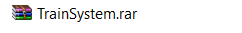
* Step 2: Open config.json with Notepad and make sure this line match with us
  + - 
* If you have any confused, please contact us to set up and update newest Train System application.

### 1.4 User Guide

* Tracking data history of Station’s working
* Step 1: Click/Run TrainSystem.exe



Figure 88: Train System Icon

* Step 2: Select Station and click Load button

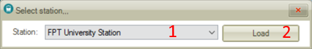

Figure 89: Choose Station

* Step 3: On the right side, there are 3 tabs: today, yesterday, search log. Select tab which be appropriate to your tracking.

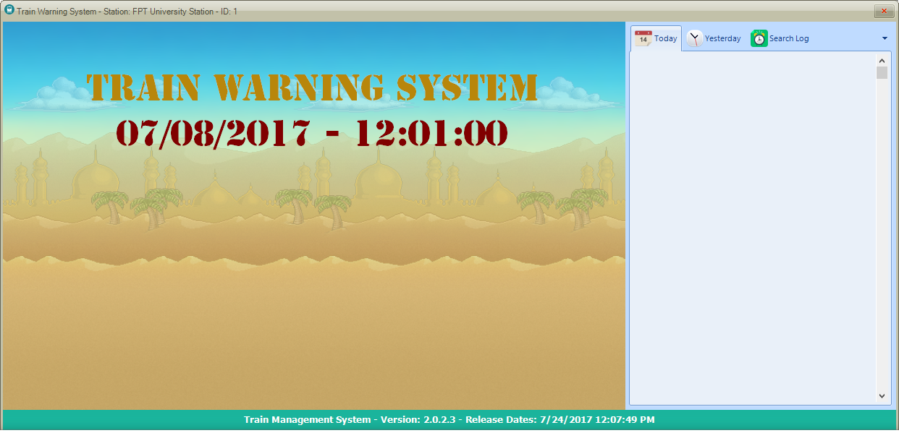

Figure 90: Main Screen

* With Search Log Tab:
* Step 1: select Time from and start date.
* Step 2: select Time to and end date.
* Step 3: Click Filtering.



Figure 91: Main Screen - Search Log

# Appendix

* **C++ Coding convention:** <https://google.github.io/styleguide/cppguide.html>
* **Arduino Mega 2560:** <http://www.atmel.com/Images/Atmel-2549-8-bit-AVR-Microcontroller-ATmega640-1280-1281-2560-2561_datasheet.pdf>
* **Arduino Pro Mini:** <https://cdn.sparkfun.com/datasheets/Dev/Arduino/Boards/ProMini16MHzv1.pdf>
* **Hall effect:** <https://en.wikipedia.org/wiki/Hall_effect>
* **RTC DS1307:** <https://datasheets.maximintegrated.com/en/ds/DS1307.pdf>

<http://arduino.vn/bai-viet/369-giao-tiep-i2c-va-su-dung-module-realtime-clock-ds1307>

* **Micro SD Card**: <https://www.arduino.cc/en/Reference/SDCardNotes>